United Federal Credit Union – Press Release
May 26, 2021

Contact: Diana Wake
Phone: (888) 982-1400 ext. 6891
Email: dwake@unitedfcu.com
United Federal Credit Union, 150 Hilltop Road, St. Joseph, Michigan, 49085

United Federal Credit Union Names Brook Sweeting
Branch Manager at Carson City North Branch
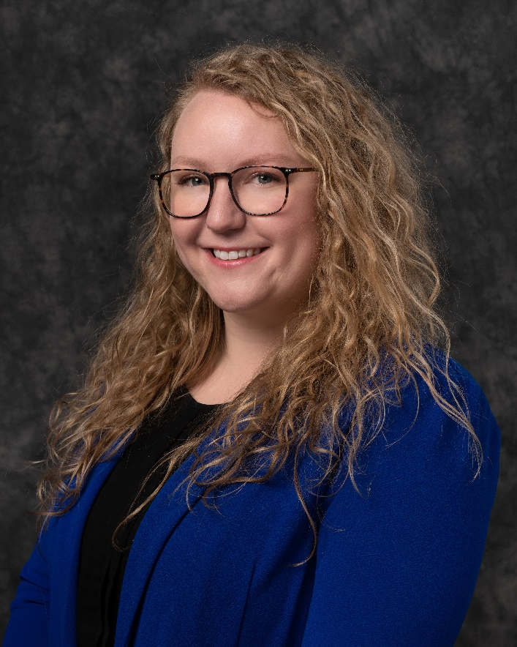
Brook Sweeting, Branch Manager, Carson City North Branch

CARSON CITY, Nev. – United Federal Credit Union (United) has named Brook Sweeting to the position of Branch Manager at its Carson City North branch 1350 E William Street.

As Branch Manager, Sweeting will be responsible for maintaining the performance of the branch, and providing leadership and supervision to staff.

Sweeting brings nearly 10 years of banking and financial experience to her new role. Prior to her role with United, she held several positions with Wells Fargo, including Branch Manager and Service Manager. She studied business finance at Kirkwood Community College.

She lives the credit union philosophy of ‘people helping people’ not only through member service, but also community involvement. Sweeting is connected with the Carson City Parks, Recreation and Open Space, and is a volunteer with the non-profit FISH (Friends In Service Helping) in Carson City.
____________
About United
United Federal Credit Union has served its Members since 1949 by helping them to build a sound financial future. United consists of more than 180,000 Member/owners worldwide and manages assets in excess of $3.6 billion. Its corporate offices and main branch are in St. Joseph, Mich., with additional branches in Arkansas, Indiana, Michigan, Nevada, North Carolina, and Ohio. Federally insured by NCUA. Equal opportunity lender. Equal housing lender. For more information visit www.unitedfcu.com

# # #

