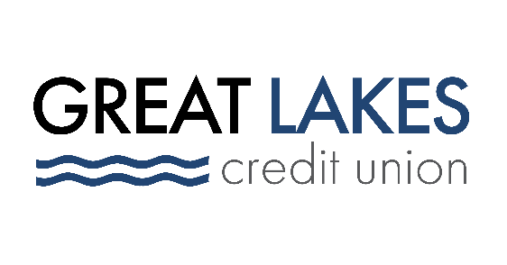

www.glcu.org
FOR IMMEDIATE RELEASE | Contact: Media Department  media@glcu.org  (847) 578-7324
Great Lakes Credit Union Board Director Receives Once in a Lifetime 2022 “Drum Major for Justice” Award

BANNOCKBURN, IL (Jan. 18, 2022) – Yesterday, Bertine “Bunny” Nixon, Emeritus Board Member of Great Lakes Credit Union (GLCU), was honored with the prestigious “Drum Major for Justice” Award at Waukegan Township’s 20th Annual Dreamers’ Event.

The event, held virtually this year, honors the life and legacy of Reverend Dr. Martin Luther King Jr. and is a chance to reflect on history and inspire action now and in the future.

The Drum Major for Justice award is presented to local community members for their service to their communities in faith, business and public life.

Nixon was honored for her service to Waukegan Township through her more than 30 years of volunteer service with the credit union on its board of directors, as well as her work with other community organizations in Waukegan and Lake County.

"I am grateful today to be able to congratulate Bertine on her well-deserved 2022 Drum Major for Justice Award, on behalf of our Board of Directors and 225 employees,” said Steve Bugg, President and CEO of GLCU.

“Bunny is a lifetime advocate of empowering individuals, and has dedicated her life to serving others in the community. Waukegan, and the individuals she has met throughout her life, are much better because of her selfless actions.”

This great honor adds to a long list of accolades for Bunny, who was named GLCU’s first Emeritus Board Member in 2020, received the Illinois Credit Union League’s 2020 Lifetime Achievement Award and was inducted into the Illinois Credit Union League Hall of Fame that same year.

In 2021, GLCU dedicated the lobby of its Waukegan branch – Nixon’s home branch – to her.

GLCU is grateful for the opportunity to support the 20th Annual Dreamer’s Event, and for the support the community of Waukegan has given to GLCU over many decades. The credit union is committed to financial empowerment for everyone, and giving back to its communities is one of the credit union’s core values.

About Great Lakes Credit Union
Founded in 1938 and headquartered in Northern Illinois, GLCU is committed to financial empowerment for you. As a not-for-profit financial cooperative with over $1 billion in assets, GLCU is proud to serve more than 80,000 members in the Chicagoland and surrounding areas. Learn more about GLCU’s accounts, educational initiatives and community development programs at glcu.org

