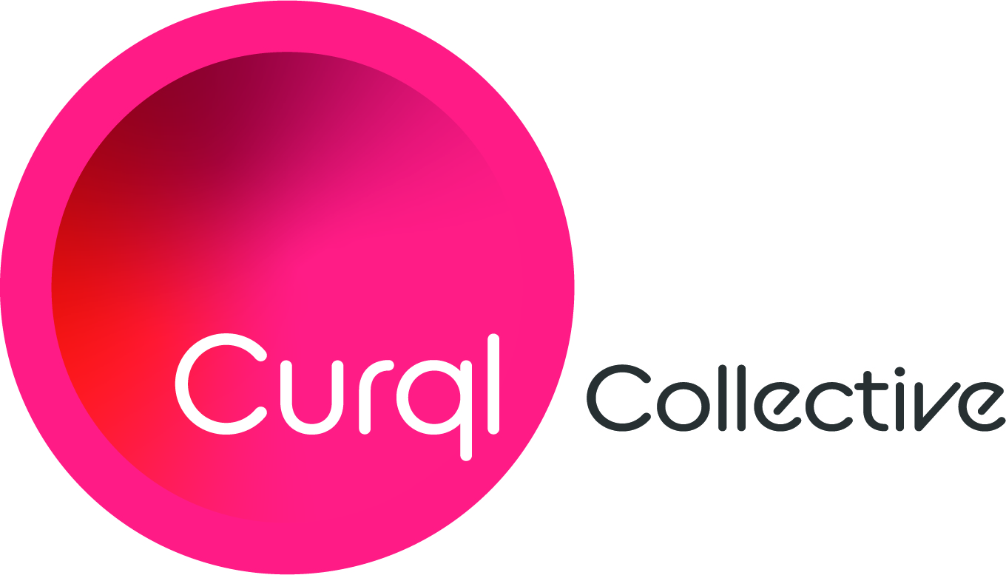
Media Contact:
Merideth Miller, M2 The Agency
281.882.3045
pr@m2theagency.com

For Immediate Release: Curql Collective Names Nick Evens as President and Chief Executive Officer

(Des Moines, Iowa) — Curql Collective (curql.com) is pleased to announce the appointment of Nick Evens as President and Chief Executive Officer. In his role, Evens will cultivate opportunities to help fintech and credit unions collaborate on breakthrough technologies that minimize threats and successfully improve, disrupt and position the industry with a best-in-class member experience.

Evens is stepping away from his role as President of The Veridian Group, Inc. (TVG), the wholly owned CUSO of Veridian Credit Union, after nearly 12 years, where he led investment strategy and direction for the $5.2B institution. During his tenure, Evens managed TVG’s more than ten direct minority investments in CUSO companies, positioning the organization with direct equity stakes in Dwolla, Alkami Technology and Moov Financial and committing approximately $10MM in six venture or seed capital funds.

“In addition to his involvement in the concept and development of Curql Collective and Curql Fund – a first-of-its-kind venture fund creating a gateway for fintech access to credit unions – Nick's investment background and board positions with fintech startups and accelerators make him the perfect fit to lead strategy and direction,” notes John Carew, Chief Strategy Officer for Georgia’s Own Credit Union and Chairman of the Board of Curql Collective. “We are excited about the innovation and collaboration he brings to Curql and our industry.”

Evens commented, “Our path at Curql Collective is to create an ecosystem to benefit fintech by generating a collaborative place for credit unions to identify, assess, partner with, and invest in transformative technology companies. I look forward to putting my experience to work as we make a serious technology commitment in ensuring continued growth and stability for the credit union industry.”

Evens remains at the helm of VentureTech, a fintech showcase event for the industry he co-founded with CUNA Strategic Services and Open Technology Solutions in 2018.

About Curql Collective

Curql Collective is a collaborative approach that brings venture capital, credit unions, and fintech together. Launched in 2020 Curql is steered by a collective of forward-thinking credit unions, including former founders, operators, and leaders in the fintech and VC spaces. The group's flagship – Curql Fund I – invests in the visions of entrepreneurs who thoughtfully and purposefully develop financial services technology that revolutionizes and innovates how people engage with their money.

-###-

