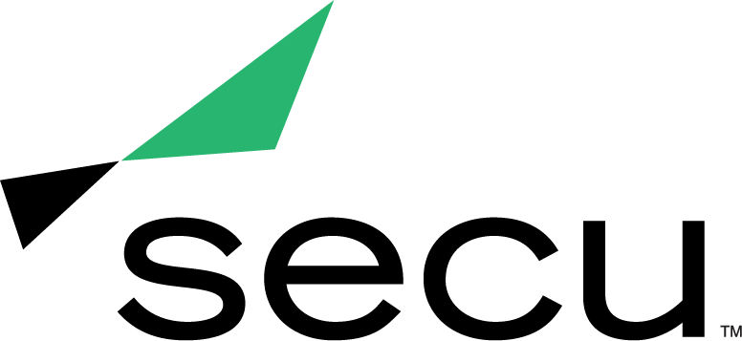
News Release

SECU Wins Two CUNA Diamond Awards
CUNA Marketing & Business Development Council presents awards for outstanding marketing achievements in Crisis Management and Financial Education

Baltimore, Md. (May 5, 2021) — SECU, Maryland’s largest state chartered credit union, is pleased to announce it has won two Diamond Awards from the Credit Union National Association (CUNA) Marketing & Business Development Council. Often recognized as the most prestigious annual credit union marketing competition, the Diamond Awards honor creative excellence and outstanding results in credit union marketing.

SECU received a Diamond Award in the new category of Crisis Management for its COVID-19 Response to support members and the community. In early 2020, during the height of the COVID-19 pandemic, SECU offered financial relief benefits to impacted members, including financial relief loans, credit card payment deferrals, financial consultative support, and educational resources on how to use digital banking tools. To address the individual financial needs of its members, SECU created an online form that enabled members to ask their unique questions and request financial support. As a result of SECU and the SECU MD Foundation’s COVID-19 relief efforts, more than $330,000 was provided to support members, the community, small businesses and school systems across Maryland.

SECU was also presented with a Diamond Award in the Financial Education category for its How-to Videos that focused on protecting members from increased fraud attempts during the pandemic. To actively promote fraud protection, the videos were continually distributed through SECU’s digital channels throughout 2020.

“Every day, it is SECU’s mission to improve the overall financial well-being of our members, whether through education or solutions that meet their personal financial needs,” said Becky Smith, EVP and Chief Strategy & Marketing Officer for SECU Maryland. “During what many would consider a difficult year, our marketing and community outreach teams have gone above and beyond to serve and give back to our members. I am so proud to work with such an amazing group of talented individuals and thrilled that other professionals within our industry have recognized their hard work.”

This year’s competition included 35 categories with more than 1,200 entries from credit unions across the U.S. During Diamond Awards Week, the CUNA Marketing & Business Development Council announced the winners in each category through a series of daily virtual award ceremonies. To view the complete list of 2021 Diamond Award winners, visit http://www.adque.com/CUNA/2021/CUNA_Menu.html.

About SECU (State Employees’ Credit Union of Maryland)
SECU ("see-Q"), Maryland’s largest state chartered credit union, serves 260,000 members across the state. As a member-owned, not-for-profit, SECU puts its members first. Membership is open to all Maryland state employees and their families, University System of Maryland students, graduates, staff and their families, Bank At Work partners and many others. Headquartered in Linthicum, Md., SECU has 22 financial centers and provides access to 30,000 free ATMs through the CO-OP network. With more than $4 billion in assets, SECU ranks among the top 60 credit unions nationwide based on total assets in the U.S. Insured by NCUA. For more information, visit www.secumd.org or follow SECU on Twitter, Facebook and Instagram.

###

Media Contact
Kelly Nguyen
knguyen@planitagency.com
609-385-6701

