FOR IMMEDIATE RELEASE

CONTACT:

Alison Barksdale, Marketing Director
972-778-0661 x 3290
alisonb@homeloancu.com
www.cumembers.com

CU Members Mortgage Partners with CUbroadcast to
Launch ‘Mortgage Monthly’ Video Talk Show

DALLAS, TX – January 8, 2021 – Leveraging video to further its message on mortgage lending trends, issues, and events for credit unions, CU Members Mortgage, a division of Colonial Savings, F.A., has partnered with CUbroadcast to launch a monthly mortgage video talk show aptly entitled: “Mortgage Monthly.” Mortgage Monthly will feature subject matter experts from CU Members Mortgage discussing a myriad of topics such as record-low interest rates, shortage of homes for sale, mortgage delinquencies, regulations, and much more. First show airs January 11, 2021.

Acccording to Steve Hewins, SVP with CU Members Mortgage, the industry is lacking a consistent broadcast of today’s mortgage lending topics. The marketplace is ever evolving and it’s sometimes a challenge to keep pace with the changes occurring on a daily basis it seems. Mortgage Monthly provides a channel to keep credit unions, as well as members, educated in this area that is so important to the industry’s well-being.

“There’s nothing really like it in our arena today,” explains Hewins. “We see this show as a fantastic opportunity to help others stay on top of mortgage lending news and take advantage of the up-to-the-minute information we have to help their members become homeowners, which will allow them to gain a firm financial footing for years to come. We’ll also share advice on how to make the most of their real estate investment, as well as all the opportunities that derive from this purchase. We’re very excited for the possibilities that Mortgage Monthly possesses.”
“As we saw how housing’s performance surprised everybody in 2020 during the pandemic, mortgage lending holds a massively significant business position at credit unions nationwide,” says CUbroadcast Host Mike Lawson. “We are proud to be partnering with CU Members Mortgage to produce, post, and promote this show each month that will ultimately help credit unions meet and exceed their mortgage lending goals, while educating their members on the many benefits of homeownership. We see it as helping credit unions increase their value with this valuable information that’s so important to their bottom line.”

About CU Members Mortgage
Established in 1982 as a division of Colonial Savings, a federally chartered thrift, Dallas-based CU Members Mortgage provides comprehensive mortgage services to credit unions and CUSOs. CU Members Mortgage originates FHA, VA, Investment Property and conventional loans nationwide. With a portfolio of $24 billion, Colonial is one of the largest servicers of mortgage loans in the United States. The company is privately held and has offices located nationwide. For more information, visit www.cumembers.com.

About CUbroadcast
CUbroadcast is a web-based credit union talk show that started in 2010. It is a collection of informative, online video interviews that address today’s credit union issues and trends with the industry’s leaders, innovators, and advocates.

CUbroadcast interviews industry experts nationwide – from credit union leaders, CUSOs, vendors, regulators, league officials, media, and more. The show aims to get their take on the latest industry trends, what can be learned from the past, and how to keep this industry moving forward better serving its millions of members now and well into the future. For more information, visit www.cubroadcast.com.

###

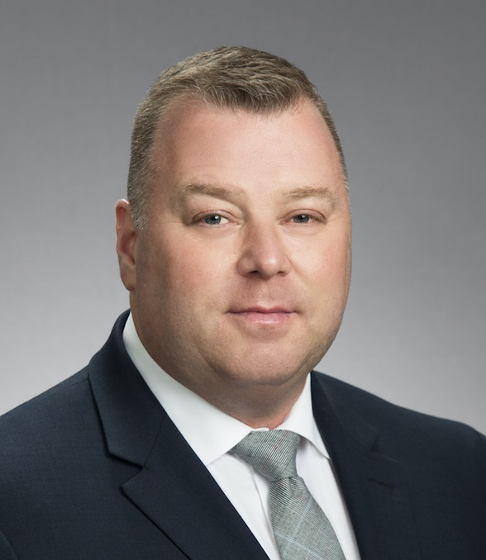 Steve Hewins, SVP with CU Members Mortgage.

