FOR IMMEDIATE RELEASE

CONTACT:
Jesse Kohl, President
InterLutions, LLC
(414) 427-3637

CUNA Strategic Services and InterLutions Connect to Deliver Enhanced Employee Benefits to Credit Unions

MILWAUKEE, WI – January 25, 2021 – InterLutions CUSO launched an alliance with CUNA Strategic Services (CSS) to provide more credit unions with access to I-Care, a pioneering employee benefits solution designed to mitigate rising health costs.

“We understand now, more than ever, the increased challenges employers face in the healthcare space, so we are excited to deliver a unique and competitive benefits solution that will collaboratively challenge the course of ever rising employee healthcare costs,” said Barb Lowman, President of CUNA Strategic Services in Madison, WI. “We believe InterLutions’ innovative offerings, leadership, and exceptional service levels align well with CUNA Strategic Service’s mission and we expect this strategic alliance to bring best-in-class value to credit unions in states where there is no healthcare solution offered through the Leagues.”

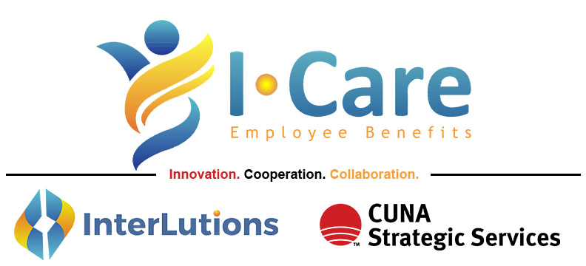

The I-Care collaborative benefits model pools the combined risk of the credit union employees they insure and leverages that credit union collective buying power to reduce health insurance costs. The expense reductions, along with big data analytics and consultative HR experts, have allowed credit unions to offer more competitive and enhanced benefit plans. This alliance provides credit unions with the flexibility to choose from a myriad of carrier networks and plan options.

Jesse Kohl, President of InterLutions said, “Similar to our new strategic alliance with CSS, our CUSO was formed by listening to credit unions in an effort to understand their primary business challenges. I-Care was designed by credit unions and now has a proven track record of success. Our clients are experiencing healthcare cost efficiencies they could not achieve previously on their own. We are truly thrilled about our alliance with CUNA Strategic Services, as it increases our ability to provide more credit unions with the improved benefits they need to retain and attract quality staff.”

The I-Care employee benefits solution works collaboratively with credit unions, a sector of the financial institutions industry that InterLutions data reports to be 23% healthier than other industries when comparing the cost of medical insurance claims made on a per employee, per year basis. Insurance carriers now recognize that credit union employees are some of the best individuals to insure, translating into expense reductions, and further allowing credit unions to offer more affordable healthcare solutions to their employees while they themselves receive enhanced reporting, more detailed claims data, and access to HR experts normally reserved for larger companies.

“Our role at CSS is to bring innovative solutions to credit unions that will drive operational excellence and growth opportunities. By offering I-Care employee benefits, we have done just that,” Lowman said.

According to InterLutions, since its inception in 2015, the I-Care community now delivers benefit solutions to nearly 10,000 individuals and offers HR departments support services via forums, conferences, workshops, and one-on-one consulting. InterLutions also hosts in-person and digital HR networking forums where credit union representatives can share insights to common benefit-management challenges.

“Whether credit unions are fully-insured, self-insured, or level funded, I-Care provides them with a one-of-a-kind collaborative employee benefits alternative that uses big data analytics, risk-management strategies, and marketplace experience to formulate solutions that put credit unions on the leading edge of delivering superior employee benefits,” Kohl said.

About InterLutions, LLC
InterLutions is a credit union service organization (CUSO) focused on providing innovative business solutions to advance the credit union movement. At its core, InterLutions believes in the idea that collaboration within the credit union industry will provide more reliable and cost-efficient ways to keep credit unions strong and healthy. Please visit InterLutionsCUSO.com to learn more and follow us on LinkedIn.

About CUNA Strategic Services, Inc.
CUNA Strategic Services, Inc., owned jointly by Credit Union National Association (CUNA) and the state leagues, saves credit unions money through its alliance program. CUNA Strategic Services, with their alliance providers, offers products and services that contribute to credit unions’ bottom lines, adds to their peace of mind, and enhances their relationships. For more information, please visit cunastrategicservices.com.

