***FOR IMMEDIATE RELEASE***

*CONTACT:*

*Jesse Kohl, President*

[*InterLutions*](https://www.interlutionscuso.com/)*, LLC*

*(414) 427-3637*

**InterLutions Presents: “Proven Case Studies That Drive Down Healthcare Costs”at REACH21 Credit Union Convention**

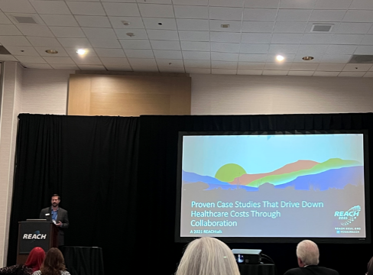**MILWAUKEE, WI – November 16, 2021** – [InterLutions](https://www.interlutionscuso.com/?utm_source=Callahan&utm_medium=press_release&utm_campaign=Convention_REACH21&utm_content=text_InterLutions), a CUSO offering [I-Care](https://www.interlutionscuso.com/I-Care/Innovation/Overview?utm_source=Callahan&utm_medium=press_release&utm_campaign=Convention_REACH21&utm_content=text_I-Care) collaborative employee benefit solutions, was selected to present a REACHtalk at REACH21, California and Nevada Leagues’ Annual Convention. The convention was held in Palm Desert, CA from November 1 through November 4.

Jesse Kohl, President of InterLutions, spoke to a group of credit union leaders about how credit unions are known to be a part of a collaborative movement that relies on data and technology to keep them thriving. He shared how credit unions can leverage their data to lower their employees' medical insurance costs and provided real statistics that prove why credit union employees are a healthier population than other industries.

Jesse Kohl presenting “Proven Case Studies That Drive Down Healthcare Costs Through Collaboration” at REACH21.

Kohl’s presentation, “Proven Case Studies That Drive Down Healthcare Costs Through Collaboration” revealed statistics about I-Care’s collaborative models that have proven to lower the credit union industry's healthcare costs and enhance employee benefit packages.

“We, as credit unions, owe it to our employees to deliver competitive benefits and to do so, we need to change our way of thinking about how we purchase insurance and deliver benefits,” said Kohl. “Through collaboration, data, and technology, credit unions *can* provide employees better benefits experiences.”

Credit unions interested in learning more about I-Care’s collaborative employee benefit solutions can visit [InterLutionsCUSO.com](https://www.interlutionscuso.com/?utm_source=Callahan&utm_medium=press_release&utm_campaign=Convention_REACH21&utm_content=text_InterLutionsCUSO.com) to watch I-Care informational and client testimonial [videos](https://www.interlutionscuso.com/About-Us/InterLutions/Informational-Videos?utm_source=Callahan&utm_medium=press_release&utm_campaign=Convention_REACH21&utm_content=text_informationalvideos).

**About InterLutions, LLC**

*InterLutions is a credit union service organization (CUSO) focused on providing innovative business solutions to advance the credit union movement. At its core, InterLutions believes in the idea that collaboration within the credit union industry will provide more reliable and cost-efficient ways to keep credit unions strong and healthy. Please visit* [*InterLutionsCUSO.com*](https://www.interlutionscuso.com) *to learn more and follow us on* [*LinkedIn*](https://www.linkedin.com/company/interlutions/)*.*