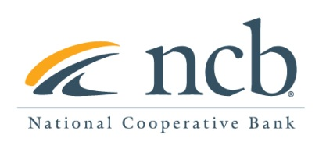
NEWS RELEASE

Contact:

Mary Alex Blanton – NCB (703) 302-8876

National Cooperative Bank Board of Directors Names Casey Fannon as CEO

Arlington, VA (March 21, 2022) – The Board of Directors of National Cooperative Bank (NCB) is pleased to announce the appointment of Casey Fannon as the bank’s new Chief Executive Officer. Mr. Fannon has been serving as the Acting CEO of NCB since the sudden death of the bank’s former CEO, Chuck Snyder, in November.
“The Board of Directors is delighted to announce that we have unanimously approved Casey Fannon as NCB’s Chief Executive Officer effective immediately,” stated Debra Huddleston, Chair of NCB’s Board of Directors. “In his 25 years at the bank, Casey has demonstrated the expertise, commitment, and passion to lead NCB into the future. The Board has great trust in Casey’s leadership and we look forward to working with him in advancing NCB’s mission.”

Since joining NCB in 1996, Mr. Fannon has dedicated his entire career to National Cooperative Bank and has served as its President since March 2020 and Acting CEO since November 2021.
“I am extremely honored to be named CEO,” stated Casey Fannon. “I look forward to working with NCB’s Board of Directors and our talented employees on growing NCB and advancing our cooperative mission.”

In addition to serving on NCB’s Board, Mr. Fannon currently serves on the Board of Directors of Capital Impact Partners, a national Community Development Financial Institution (CDFI), and The National Grocers Association (NGA), a national trade association representing the retail and wholesale community grocers nationwide.
Mr. Fannon received a BS in Finance from Bentley University and is a Chartered Financial Analyst charter holder.

About National Cooperative Bank:

National Cooperative Bank is dedicated to strengthening communities nationwide through the delivery of banking and financial services, complemented by a special focus on cooperative expansion and economic development. NCB provides financial products and services for the nation’s cooperatives, their members, and socially responsible organizations. Headquartered in Washington, DC, the Bank has offices in Alaska, California, New York, Ohio, and Virginia. To learn more, visit www.ncb.coop, National Cooperative Bank on Facebook and Instagram, or Twitter @natlcoopbank.

