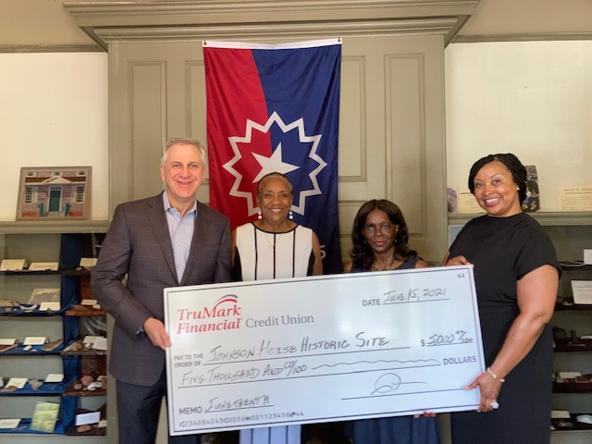
TruMark Financial CEO Richard F. Stipa and VP Human Resources Director, Diversity Office Kimberly Hinton (far right), present a $5,000 donation to Johnson Historic Site representatives Patricia Bass (2nd from left) and Cornelia Swinson to commemorate Juneteenth Day. Officially celebrated on June 19, Juneteenth Day marks the end of slavery in the United States.

