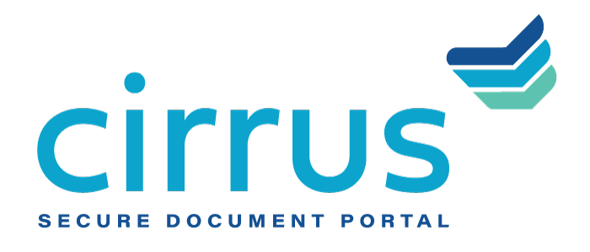
MEDIA CONTACT:
Augusta Bauknight
augusta@williammills.com
678-781-7214

Cirrus Taps Alex Dean as New National Sales Director

Follows addition of new Chief Strategy Officer, John DeMoss, as company expands executive team to support market demand and organizational growth

EVERGREEN, Colo. – Jan. 7, 2021 – Cirrus, a provider of cloud-based document management software, announced the addition of Alex Dean as the company’s new National Sales Director. Dean will be working closely with John DeMoss, who also joined the company recently as its new Chief Strategy Officer as part of an expansion of Cirrus’ executive team in response to increased market demand for its secure document collection and collaboration portal. In his new role, Dean will be responsible for growing sales, reaching competitive markets within the financial industry and extending the reach of Cirrus’ solutions.

Dean brings financial services experience to his new role, having previously served as Senior Business Development Officer at AFCO Credit Corporation where he oversaw new business development, onboarded brokers accounts and led strategic selling initiatives, realizing an increase in profitability by more than 85% year-over-year. Dean also brings proven operations and development experience gained through work with Nashville-based organizations Kano Laboratories (industrial manufacturer) and Central Parking System (parking and transportation management).

“I am thrilled to be part of a team that not only has a deep understanding of the industry and operational knowledge of financial institutions’ loan operations, but also a deep commitment to delivering solutions that help lenders more profitably manage their loan pipelines,” said Dean.

“Alex has a proven track record of growing sales while also developing lasting relationships based on character, integrity, and hard work,” said David Brooks, founder and CEO, Cirrus. “As lenders continue managing excessive loan pipelines, including those resulting from COVID, there is a tremendous market opportunity for our solutions. We look forward to working with Alex to help extend the impact of our products and services to the marketplaces we serve.”

About Cirrus
Cirrus provides a digital client engagement tool that eliminates the “document chaos” associated with the management of commercial and SMB bank account onboarding and lending documentation to deliver a superior customer experience for clients in the banking, healthcare, agricultural and oil and gas industries, among others. Using a cloud-based, API-enabled system, financial institutions are able to create electronic checklists, collaborate on documents needed at each stage of the deal, upload sensitive documents quickly and securely, and easily view the status of the deal itself. Thoughtfully designed by bankers for bankers, Cirrus brings a policy-driven structure to its clients and is committed to returning 10 million hours of operational savings to the banking industry. For more information, visit www.cirrussecure.com.

###

