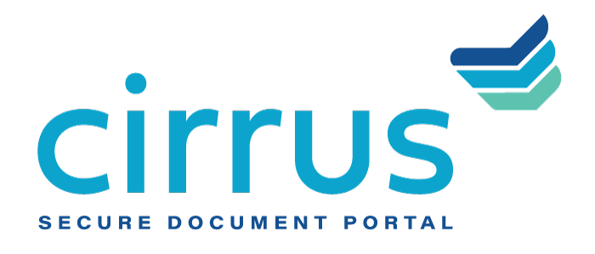
MEDIA CONTACT:
Augusta Bauknight
augusta@williammills.com
678-781-7214

Cirrus Adds Aubrey McCarthy as Director of Client Success

McCarthy joins team to accommodate company growth and support Cirrus’ proven, service-oriented approach

EVERGREEN, Colo. – Mar. 8, 2021 – Cirrus, a provider of cloud-based document management software, is expanding its client success team to support increased execution and planning in response to growing market demand for its solutions with the addition of Aubrey McCarthy as its new Director of Client Success.

Leveraging nearly 15 years of proven experience, McCarthy helps Cirrus ensure a transparent, collaborative and secure lending experience for its clients. With McCarthy’s extensive knowledge in fostering and refining customer relationships, Cirrus is positioned to provide its customers with the highest level of service to support their businesses and transform the customer journey.

“A service-oriented philosophy is foundational to a company’s success, but more importantly, to our clients’ success,” said McCarthy. “Cirrus’ cloud-based portal is truly unique within the industry, offering a valuable tool for managing the entire document collection process. I look forward to helping the team continue to deliver an enhanced customer experience that empowers our clients to be even more successful within today’s competitive landscape.”

Most recently, McCarthy served as global manager of customer onboarding for Conga, where she led the development and implementation of the company’s strategic global customer onboarding program. There, she improved Conga’s customer satisfaction (CSAT) and net promoter scores (NPS), as well as increasing adoption and time-to-value. Prior to Conga, she gained experience as the customer success manager for RingCentral, advising and overseeing strategic deployments for enterprise-level customers.

“As a self-proclaimed ‘customer success fanatic’ with nearly 15 years of client-facing experience, Aubrey has a deep understanding of the customer journey,” said David Brooks, founder and CEO, Cirrus. “The collection and collaboration of loan documents is a tedious task that can hinder a customer’s overall satisfaction and experience with their FI. Between our solutions and Aubrey’s expertise, we are confident that our clients are equipped to better achieve sustained, long-term success.”

About Cirrus
Cirrus provides a digital client engagement tool that eliminates the “document chaos” associated with the management of commercial and SMB bank account onboarding and lending documentation to deliver a superior customer experience for clients in the banking, healthcare, agricultural and oil and gas industries, among others. Using a cloud-based, API-enabled system, financial institutions are able to create electronic checklists, collaborate on documents needed at each stage of the deal, upload sensitive documents quickly and securely, and easily view the status of the deal itself. Thoughtfully designed by bankers for bankers, Cirrus brings a policy-driven structure to its clients and is committed to returning 10 million hours of operational savings to the banking industry. For more information, visit www.cirrussecure.com.

###

