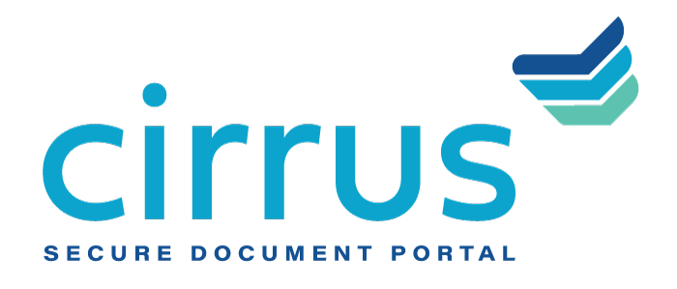
MEDIA CONTACT:
Augusta Bauknight
augusta@williammills.com
678-781-7214

Cirrus Announces Strategic Partnership With Manifesto

Partnership features capital raise, corporate branding initiatives for Cirrus

EVERGREEN, Colo. – Feb. 22, 2021 – Cirrus, a provider of cloud-based document management software, announced a capital investment from Portland and Milwaukee-based branding agency Manifesto, that will also coincide with a corporate branding campaign that Manifesto is leading.

As financial institutions continue to invest heavily in digital transformation and enhanced customer experiences, Cirrus’ cloud-based system plays a key role in supporting a more streamlined, user friendly commercial and SMB lending process. By automating the collection and collaboration of loan documents, Cirrus’ bank and credit union customers can better manage extensive loan requests and provide quicker access to capital for small businesses – important today as businesses continue to cope with the effects of the pandemic and important in the future as institutions work to grow their business and commercial loan portfolios.

“As a company that strives to challenge the status quo, we felt that our organizational ethos aligned closely with the culture of Cirrus,” said Dave Dyer, CEO & Managing Partner, Manifesto. “We partner with courageous humans and ambitious brands and we realize the human impact within banking is often overlooked. We’re excited to bring human-centric storytelling to Cirrus as we evolve their brand and presence in the marketplace.”

“We find ourselves at an inflection point in terms of how financial institutions serve their business customers,” said David Brooks, founder and CEO, Cirrus. “Cirrus’ portal is proven in its ability to help institutions better collaborate, rapidly execute and quickly scale to support application volume from businesses that need fast access to funding in order to survive in a challenging economic environment. This partnership with Manifesto will play a key role in furthering our mission to eliminate the ‘document chaos’ that limits banks’ ability to serve their customers in the most modern, efficient manner possible.”

About Cirrus
Cirrus provides a digital client engagement tool that helps banks become more productive and profitable by accelerating document collection, collaboration and deal flow. Cirrus eliminates the “document chaos” associated with the management of commercial and SMB bank account onboarding and lending documentation to deliver a superior customer experience for clients in the banking, healthcare, agricultural and oil and gas industries, among others. Using a cloud-based, API-enabled system, financial institutions are able to create electronic checklists, collaborate on documents needed at each stage of the deal, upload sensitive documents quickly and securely, and easily view the status of the deal itself. Thoughtfully designed by bankers for bankers, Cirrus brings a policy-driven structure to its clients and is committed to returning 10 million hours of operational savings to the banking industry. For more information, visit www.cirrussecure.com.

About Manifesto
Manifesto is a nationally award-winning branding and creative agency with offices in Portland, OR and Milwaukee, WI that specializes in branding and strategy, integrated campaigns, and brand activation. Founded by twin brothers, Tim and Dave Dyer, Manifesto exists to rally humans around the heart and soul of the world’s most ambitious brands. For more information, visit www.manifestoagency.com.

###

