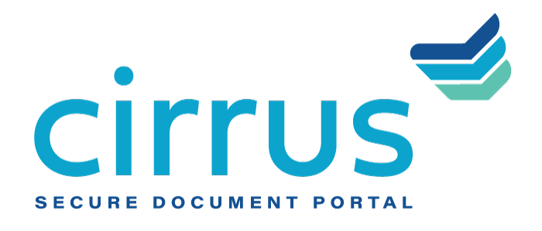
MEDIA CONTACT:
Augusta Bauknight
augusta@williammills.com
678-781-7214

Cirrus Supports Pursuit In Bringing Financial Assistance To Small Businesses Through Queens Small Business Grant Program

Cirrus portal streamlines loan application and funding for Queens, NYC-based small businesses impacted by COVID-19

EVERGREEN, Colo. – May 4, 2021 – Cirrus, a provider of cloud-based document management software, announced that Pursuit leveraged Cirrus’ secure document collection and collaboration portal as a key component of the NYC-based Queens Small Business Grant Program.

In response to the challenges facing small businesses in the wake of COVID, the New York City Economic Development Corporation partnered with Pursuit and several community-based organizations to offer grants to Queens-based, minority-owned small businesses heavily impacted by the pandemic. The program offers up to $20,000 to support operational expenses to first-floor storefront businesses, second-floor restaurants and street vendors with less than 20 employees located in Queen’s low- and moderate-income communities.

As the application and decision portal for these COVID-relief grants, Cirrus’ cloud-based, API-enabled system supports the collaboration and collection of loan files to streamline and automate the document management process. Cirrus expedited the entire process for small businesses in the program, successfully managing nearly $14 million in grants for 745 businesses. Out of these businesses, 90% were either minority- or women-owned. Additionally, the Queens Small Business Grant Program has dedicated $2.5 million to further support small businesses later in 2021.

“Small businesses are hardest hit by COVID, and the Queens Small Business Grant Program could be the deciding factor in whether these businesses close their doors or remain operational,” said David Brooks, founder and CEO, Cirrus. “The issue is that between processing, managing and collecting documents, the application process can very quickly become overwhelming to even the most seasoned and experienced organization. Our platform eliminates this ‘document chaos,’ streamlining the collection and collaboration workflow through a secure portal to help these businesses gain access to needed capital more quickly.”

“The Cirrus platform created a way for resource-strapped small business owners to apply for this critical program quickly and easily,” said Rachel Van Tosh, chief operations officer, Pursuit Community Finance. “The technology also provided the tools required to operate a large program at scale and maximize our team’s human capital.”

About Cirrus
Cirrus provides a digital client engagement tool that eliminates the “document chaos” associated with the management of commercial and SMB bank account onboarding and lending documentation to deliver a superior customer experience for clients in the banking, healthcare, agricultural and oil and gas industries, among others. Using a cloud-based, API-enabled system, financial institutions are able to create electronic checklists, collaborate on documents needed at each stage of the deal, upload sensitive documents quickly and securely, and easily view the status of the deal itself. Thoughtfully designed by bankers for bankers, Cirrus brings a policy-driven structure to its clients and is committed to returning 10 million hours of operational savings to the banking industry. For more information, visit www.cirrussecure.com.

###

