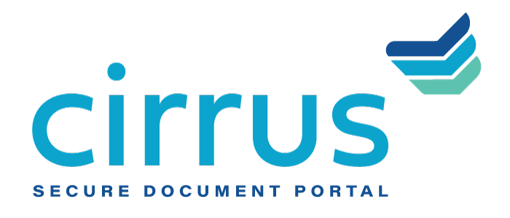
MEDIA CONTACT:
Augusta Bauknight
augusta@williammills.com
678-781-7214

Cirrus Adds Treasury Services Capabilities To Its Document Management Solution Suite

Provides secure centralization of documentation, optimizes internal workflows

EVERGREEN, Colo. – June 1, 2021 – Cirrus, a provider of cloud-based document management software, announced the addition of treasury workflow tools to its solutions suite. As a proven provider of document workflow services for commercial lending, Cirrus has responded to requests for similar capabilities specifically tailored to supporting financial institutions’ treasury department onboarding processes, as well.

Much like commercial lending, treasury services often require the coordination of numerous pieces of documentation from multiple stakeholders within a secure, fully compliant environment. Cirrus’ cloud-based, API-enabled solution enables bankers to significantly streamline these processes on behalf of their customers and frees up valuable operational time for their institutions. For financial institutions that leverage identity verification tools and document archival resources, Cirrus’ built-in integrations streamline even more workflow and further elevate the customer experience.

“In many ways, treasury is the life blood of an institution, but much like commercial and SMB lending, treasury has long been overdue for digital innovation that can positively impact operations,” said David Brooks, founder and CEO, Cirrus. “At Cirrus, we use our experience as bankers and understanding of the industry to guide our development and it is with that level of understanding – of what bankers truly need to succeed in their work – that we bring our new treasury capabilities to market.”

About Cirrus
Cirrus provides a digital client engagement tool that eliminates the “document chaos” associated with the management of commercial and SMB bank account onboarding and lending documentation to deliver a superior customer experience for clients in the banking, healthcare, agricultural and oil and gas industries, among others. Using a cloud-based, API-enabled system, financial institutions are able to create electronic checklists, collaborate on documents needed at each stage of the deal, upload sensitive documents quickly and securely, and easily view the status of the deal itself. Thoughtfully designed by bankers for bankers, Cirrus brings a policy-driven structure to its clients and is committed to returning 10 million hours of operational savings to the banking industry. For more information, visit www.cirrussecure.com.

###

