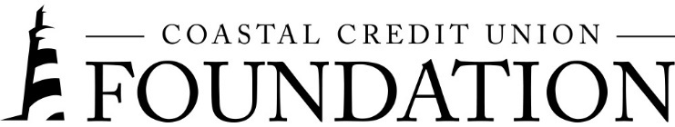
NEWS RELEASE
Contact: Joe Mecca
VP, Communication / Spokesperson
919-420-8044 / jmecca@coastal24.com
FINAL – For Immediate Release

Coastal Credit Union Foundation Announces Latest Grants;
Reaches $3 Million Giving Milestone

RALEIGH, N.C. (September 1, 2021) – The Coastal Credit Union Foundation has announced the latest round of grants to benefit nonprofit organizations in the community. In August, the foundation issued $157,500 in new funding to five recipients. In doing so, the foundation has surpassed $3 million in grants since it was formed in 2011.

The grants include $50,000 for the United Way of the Greater Triangle’s 10 to Watch Program. 10 to Watch addresses racial, gender and power disparities in leadership among the local nonprofit community. Both the credit union and its foundation have supported the program since it began, with Coastal making the first $25,000 pledge to the program in 2018.

An additional $50,000 grant was made to Boys and Girls Clubs Serving Wake County, to support Project Great Futures, which focuses on academic success, healthy lifestyles, and leadership and character development. Other grant recipients include: Step Up Ministry, Alliance Medical Ministry: and Triangle Family Services.

Year to date, the Coastal Credit Union Foundation has made $280,500 in grants.

The mission of the Coastal Credit Union Foundation is to enrich the lives of our members and their communities by providing financial support to 501(c)(3) organizations, particularly in the 16-county market of Central North Carolina. Learn more at www.coastal24.com/foundation/.

###

