141 Harvest Lane
Williston VT 05495
(802) 879-8790
www.nefcu.com
www.facebook.com/NEFCUVT
www.twitter.com/NEFCU
www.linkedin.com/company/new-england-federal-credit-union

NEFCU NEWS RELEASE
FOR IMMEDIATE RELEASE
DATE: October 6th, 2021
CONTACT: Bill Smith, Chief Marketing and Retail Officer; (802) 879-8705; smith@nefcu.com

KARA DANAHER JOINS NEFCU AS MORTGAGE LOAN OFFICER

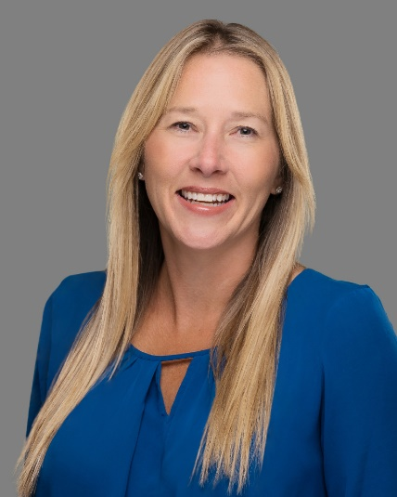

NEFCU Williston, VT— New England Federal Credit Union (NEFCU) announced recently that Kara Danaher has joined the credit union as a Mortgage Loan Officer.

Kara is a native Vermonter who graduated from the University of Vermont (UVM) with a degree in Education and a concentration in Mathematics. After a successful career as a real estate agent that began in 2013, Kara chose to pursue new challenges in mortgage financing.

Kara lives in Colchester with her husband and three children. When not helping people realize their financial goals, she enjoys baking, traveling with her family, and playing outside with her children.

-30-
New England Federal Credit Union (NEFCU), headquartered in Williston, Vermont is a member-owned financial institution serving communities in twelve counties of Vermont: Addison, Bennington, Caledonia, Chittenden, Franklin, Grand Isle, Lamoille, Orange, Rutland, Washington, Windham, and Windsor; and four counties in New Hampshire: Cheshire, Grafton, Merrimack, and Sullivan. For more information about membership requirements and benefits, visit nefcu.com.

