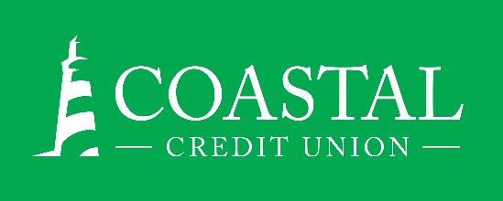
NEWS RELEASE
Contact: Joe Mecca
VP, Communication / Spokesperson
919-420-8044 /jmecca@coastal24.com
FINAL – For Immediate Release

Coastal Credit Union’s Daymark Realty Reaches
Four Million Dollar Savings Milestone

RALEIGH, N.C. (November 23, 2021) – Coastal Credit Union’s real estate subsidiary, Daymark Realty, reached another milestone this month, having saved Coastal members more than $4 million in real estate fees since the service launched in 2007. Savings are calculated as the difference between the listing fees that members pay versus typical fees noted in the market.

Daymark offers members an experienced agent and full-service real estate brokerage for a member-exclusive listing fee of just 4.5%, compared to the 6%, or more, charged by many brokers. Non-members can also use Daymark and pay only 5%, saving 1% from traditional brokers.

“Member savings from Daymark have grown to more than a half million dollars every year, and are becoming a growing part of Coastal’s overall Member Giveback,” said Louis Guillama, VP of Real Estate Operations. “We save the average seller over $5,600 in fees while providing more services and a more experienced agent. Members who use a Daymark Realtor® to buy a home also receive a $500 cash rebate at closing.”

“We call these the Daymark Advantage,” added Guillama. “We provide credit union members with an experienced Realtor®, offering comprehensive services, at a significantly lower price. Add in the rebate for also buying through us, and the savings from using Coastal for your mortgage, and it becomes a tremendous member benefit.”

About Daymark Realty:
Daymark Realty is a full-service real estate company, wholly-owned by Coastal Credit Union. Daymark is a member of the Triangle Multiple Listing Service (MLS), Rocky Mount Area Association of Realtors® and North Carolina Regional MLS. Every Daymark Realtor® is a member of the National Association of Realtors®, North Carolina Association of Realtors® and Raleigh Regional Association of Realtors®.

About Coastal
Coastal Credit Union is a not-for-profit, member-owned, financial cooperative, offering a full range of financial products and services. Coastal was chartered on August 31, 1967 with the mission of fostering the credit union philosophy of “people helping people.” Today, with $4.49 billion in assets, Coastal serves 296,000 members from 1,800 business partners and is among the leading financial institutions in North Carolina. Coastal operates 23 branches in central North Carolina and serves members in all 50 states through a network of 5,000 shared branches, 30,000 surcharge-free ATMs, mobile banking featuring mobile check deposit, and a robust offering of online services at www.COASTAL24.com. For more Coastal news, visit our online newsroom.
###

