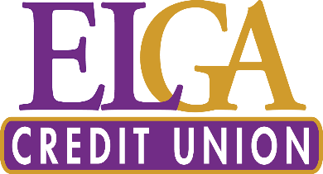
FOR IMMEDIATE RELEASE:
September 29, 2021

Contact: Cheryl Sclater
(810) 600-2529
cheryl.sclater@elgacu.com

ELGA Credit Union Foundation for Impact delivers more than $45,000 to Hurley Children’s Hospital
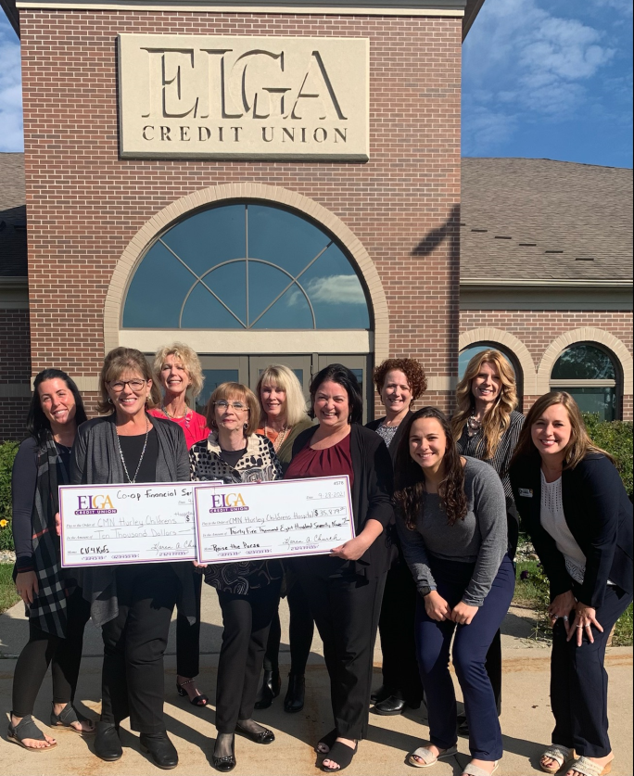
ELGA CU Foundation for Impact representatives and ELGA CU associates present Linda Tracy-Stephens, Children’s Miracle Network Hospitals Director, with proceeds from the "Raise to Purse" fundraising event on Tuesday, September 28th.

BURTON, Mich. – The ELGA Credit Union Foundation for Impact raised $35,879 to benefit Hurley Children’s Hospital – Flint’s own Children’s Miracle Network (CMN) hospital, at its inaugural fundraising event “Raise the Purse” on Friday, September 17th. In a surprise announcement, CO-OP Financial Services donated $10,000 through its “Miracle Match” program, bringing the grand total donated to $45,879!
– more –
“We are so appreciative of all that ELGA Credit Union has done for Hurley Children’s Hospital over the years,” said Linda Tracy-Stephens, Children’s Miracle Network Hospitals Director. “This financial support means a lot to our young patients at Hurley Children’s Hospital, and to the various units that benefit from community support including the Neonatal Intensive Care Unit, the Pediatric units, and the Oncology/Sickle Cell clinic.”
Hurley Children’s Hospital is a nationally recognized pediatric program providing the most outstanding clinical care for children and their families, and a CMN Hospital. Children’s Miracle Network is the charity of choice for credit unions across the United States, supported through Credit Unions for Kids – a nonprofit collaboration of credit unions, chapters, leagues/associations and business partners from across the country, engaged in fundraising activities to benefit 170 Children’s Miracle Network Hospitals. Credit unions are the 5th largest sponsor of CMN Hospitals.
“The Raise the Purse event was a fun, high-energy event. We are grateful to ELGA for their ongoing support and for helping us fulfill our mission: “We save children’s lives and we give families hope,” said Brooklyn Kennings, Assistant Director for CMN Programs.
Event attendees bid on and purchased new and used designer purses and packages which included $2,500 merchandise certificate to Neiman Marcus, a specialty bag donated by Saks Fifth Avenue, lunch with Genesee County Sheriff Chris Swanson, and several Louis Vuitton bags donated by sponsors. Attendees enjoyed a fun evening, including a taco bar and margaritas. Sheriff Swanson brought high energy to the event, serving as auctioneer.
About ELGA Credit Union
Serving members since 1951, ELGA Credit Union is a not-for-profit cooperative; formed, owned and operated with a single purpose: People Helping People. Simply put, anyone who lives, works, worships, volunteers, or attends school in the State of Michigan is eligible to join. To learn more about ELGA Credit Union, visit www.ELGACU.com.

###

