FOR IMMEDIATE RELEASE:
December 15, 2020

Contact: Cheryl Sclater
(810) 600-2529
Cheryl.Sclater@elgacu.com

ELGA Credit Union and the Michigan State Police Raise $18,306 to save Christmas for local kids
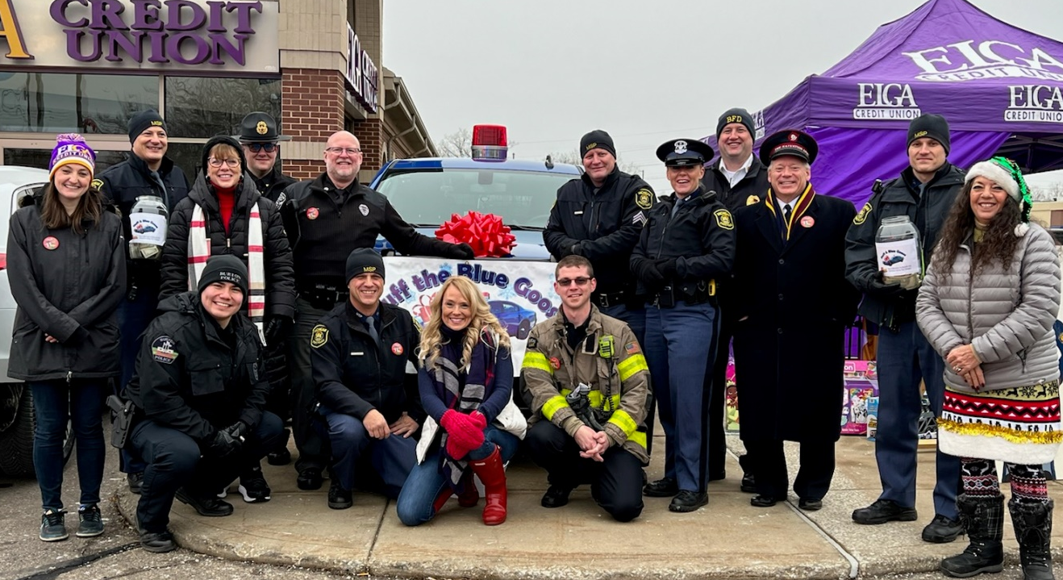

BURTON, Mich. – Families from all over Genesee, Shiawassee and Lapeer counties will have toys under the tree this year thanks to ELGA Credit Union (ELGA) and the Michigan State Police Flint Post (MSP), who hosted Stuff a Blue Goose on Friday, December 3rd. After another successful year, the event raised $18,306.23, and collected 1,481 toys. This annual event benefits the Salvation Army’s Christmastown Toy Shoppe, and every penny raised and toy collected stays within the local community. This year, more than 1,400 children are registered to receive these toys from the Salvation Army.

– more –
“The Salvation Army is honored to be the benefactor of the annual Stuff a Blue Goose event,” said Major Randy Hellstrom of the Salvation Army. “The toys and money raised through this event are the largest single donation day of the year. The people we work with at ELGA Credit Union and the Michigan State Police are amazing, and we are blessed to have their support of our Christmas assistance program, Christmastown. This year, more than 1,400 children will be blessed on Christmas morning!”
Donations were collected at 13 ELGA Credit Union locations by local police and fire departments, along with ELGA associates and Salvation Army representatives. Monetary donations were also made online. ELGA Credit Union and its associates, the MSP, and the community as a whole have come together to make this possible.
“I can’t express the gratitude we feel each year as the community supports this wonderful event,” said ELGA Public Relations Manager Cheryl Sclater. “We couldn’t provide Christmas for so many families without the toys or the dollars and change that are brought in by so many in our community. Thank you to each and every one of you who continue to support this incredible cause.”
About ELGA Credit Union
Serving members since 1951, ELGA Credit Union is a not-for-profit cooperative; formed, owned and operated with a single purpose: Members Helping Members. Simply put, anyone who lives, works, worships, volunteers, or attends school within Genesee, Saginaw, Lapeer, Shiawassee, Oakland, and Livingston Counties are eligible to join. To learn more about ELGA Credit Union, visit www.ELGACU.com.
###

