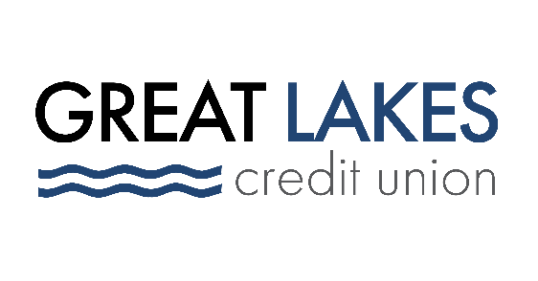

www.glcu.org
FOR IMMEDIATE RELEASE | Contact: Media Department  media@glcu.org  (847) 578-7310
Great Lakes Credit Union Expands Field of Membership to Include all of Cook County and Chicago

BANNOCKBURN, IL (Mar. 9, 2022) – Great Lakes Credit Union (GLCU) has expanded its field of membership to include more communities within Cook County. The expansion enables the $1 billion-asset credit union, headquartered in Bannockburn, Illinois, to serve the entirety of Cook County including Chicago’s lakefront; its North Shore communities; and communities to the west including Skokie, Albany Park and North Park.

“This is a milestone in GLCU history,” said Steven Bugg, President and Chief Executive Officer.
“With all of Cook County now in our field of membership, we will be able to make an even greater impact in our communities.”

Over time, GLCU has evolved from focusing exclusively on the needs of existing members to focusing also on the communities in which they live. The credit union’s extensive list of products and services positions them to assist both affluent and underserved individuals, businesses, and non-profit organizations with their financial needs.

As a low-income designated credit union, the core of GLCU’s strategy is ensuring a portion of its resources – both people and profits – serve its local underserved communities.

“If you take at face value our expansion into communities in Northern Chicago and its North Shore suburbs, it’s tempting to suggest we’re going off-strategy,” said Bugg. “But serving our mid-market and upscale consumers enables us to generate resources to invest in the underserved markets that need us now more than ever.”

And those more affluent consumers appreciate doing their banking with a mission-driven financial institution, Bugg adds.

“They feel good knowing they’re not just bettering their own finances. It’s wonderful to get good rates but when you know that in addition, you’re helping to provide financial education that empowers generations of families, you feel you’re a part of something bigger than yourself. That matters to a lot of people.”

In addition to partnering with local non-profits and schools to provide financial education, GLCU is one of only eight credit unions nationally that serves as a housing counseling agency approved by the U.S. Department of Housing and Urban Development (HUD). Through this recent membership expansion, GLCU will be able to expand its free housing and financial counseling to Chicago residents and surrounding Cook County communities

About Great Lakes Credit Union
Founded in 1938 and headquartered in Northern Illinois, GLCU is committed to financial empowerment for you. As a not-for-profit financial cooperative with over $1 billion in assets, GLCU is proud to serve more than 80,000 members in the Chicagoland and surrounding areas. Learn more about GLCU’s accounts, educational initiatives, and community development programs at glcu.org

