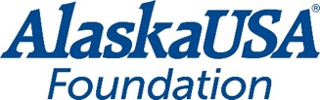

FOR IMMEDIATE RELEASE

July 20, 2021

First Alaska USA Foundation Fairway Friends Golf Tournament Raises $130,000 for Local Nonprofits

Anchorage, Alaska – Meeting friends on the fairway to support Armed Services YMCA Alaska (ASYMCA) and Covenant House Alaska was the goal of 140 golfers as they participated in the first Alaska USA Foundation Fairway Friends Golf Tournament July 8 at the Anchorage Golf Course. The tournament brought business partners, credit union leaders and the community together to support these organizations.

“The Alaska USA Foundation is committed to supporting needs-based organizations like ASYMCA and Covenant House Alaska. We are so thankful that our business partners and community were eager to sponsor the first Foundation golf tournament and support these amazing organizations and the critical work they are doing,” said Alaska USA Foundation President Geoff Lundfelt.

This sold-out event raised $130,000 with $65,000 going to Cancer Support Community Alaska’s ASYMCA’s mission of enhancing the lives of military members and their families in spirit, mind, and body through programs relevant to the unique challenges of military life and $65,000 to support Covenant House’s mission of providing compassionate, sustainable services and shelter to homeless or at-risk youth in Alaska.

The Alaska USA Foundation Fairway Friends Golf Tournament will be an annual Foundation event, providing the opportunity for Foundation nonprofit partners to benefit from this fun fundraiser.

More About Alaska USA Foundation

For more than fifteen years, the Alaska USA Foundation has supported 501(c)(3) charitable organizations that provide needs-based services to children, veterans, and active-duty members of the military and their families. Since its inception, the Foundation has distributed more than $2.5 million to these organizations and is honored to assist those that provide direct services in support of its mission. Additional information about the Alaska USA Foundation is available at alaskausafoundation.org.

-more-
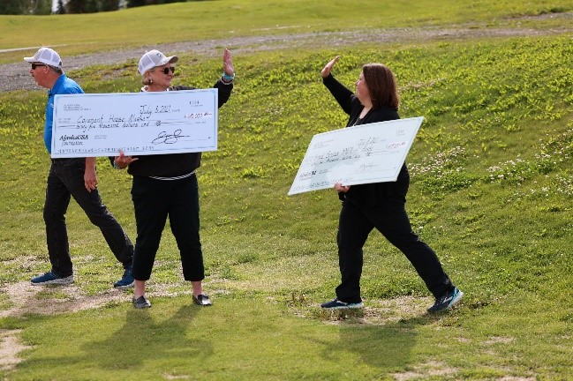
Photo: Covenant House Alaska and Armed Services YMCA of Alaska receive $65,000 each at the Fairway Friends Golf Tournament.

###

Media Contact
Dan McCue
Executive Director, Alaska USA Foundation
907-786-2807
D.McCue@alaskausa.org

