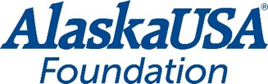
FOR IMMEDIATE RELEASE

November 17, 2021

Media Contact
Dan McCue
Executive Director
Alaska USA Foundation
907-786-2807
D.McCue@alaskausa.org

Alaska USA Foundation Fairway Friends Golf Tournament Raises $125,000 for Local Nonprofit

Phoenix, AZ – Playing where the pros play and supporting Cancer Support Community Arizona (CSCAZ) was the goal of more than 150 golfers as they participated in the Alaska USA Foundation Fairway Friends Golf Tournament November 8. The tournament was the opening day charity event for the PGA Tour Champions Charles Schwab Cup Championship held November 11-14 at the historic Phoenix Country Club. The tournament brought business partners, credit union leaders and the community together to support CSCAZ.

“The Alaska USA Foundation is committed to supporting needs-based organizations in the communities we serve. We are so thankful that our business partners and community were eager to sponsor the first Foundation golf tournament in Arizona to help us support this amazing organization and the critical work they are doing,” said Geoff Lundfelt, President of the Alaska USA Foundation.

This sold-out event raised $125,000 to support CSCAZ’s mission of ensuring that all people impacted by cancer are empowered by knowledge, strengthened by action and sustained by community.

The Alaska USA Foundation Fairway Friends Golf Tournament will be an annual Foundation event, providing the opportunity for Foundation nonprofit partners in Arizona to benefit from this fun fundraiser.

More About Alaska USA Foundation

For more than 18 years, the Alaska USA Foundation has supported 501(c)(3) charitable organizations that provide needs-based services to children, veterans, and active-duty members of the military and their families. Since its inception, the Foundation has distributed more than $3 million to these organizations and is honored to assist those that provide direct services in support of its mission. Additional information about the Alaska USA Foundation is available at alaskausafoundation.org

-more-

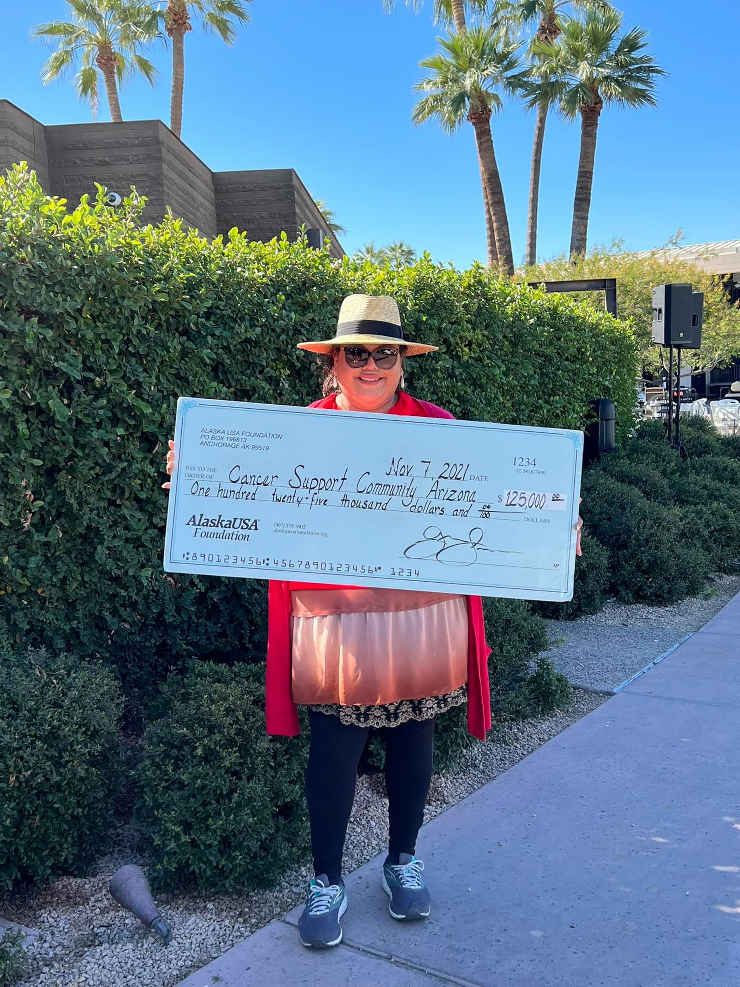
Photo: Cancer Support Community Arizona receives $125,000 at the Fairway Friends Golf Tournament in Arizona.

###

