PRESS RELEASE

CONTACT:
Courtney L. Brown
Vertical Strategy & Marketing Partner
FedChoice Federal Credit Union
cbrown@fedchoice.org
301.699.6100 x 4455

Lanham, MD (February 17, 2022) -

Armed with the knowledge that socks are one of the most needed, but least donated items in shelters across the United States, FedChoice Federal Credit Union joined the mission to supply this important clothing item to those in need. Clean, dry socks are essential for comfort, and there are so many other benefits, such as preventing a myriad of foot related irritations and problems.

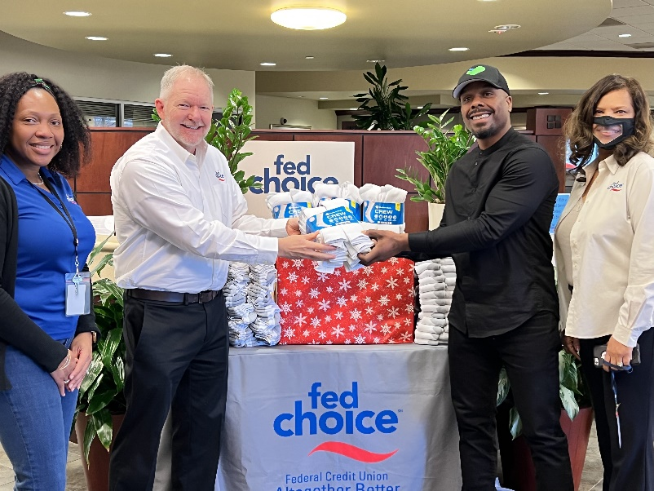
FedChoice put collection boxes in our Lanham Financial Service Center so members and employees could fill them with new socks for homeless men and women in the Washington, DC Metro area. FedChoice partnered with a local non-profit, S.O.C.K.S Movement. to ensure the socks are delivered to the individuals who need them most.

Damon Jones, the founder of S.O.C.K.S, was appreciative of the generous donation from FedChoice and its members. The S.O.C.K.S Movement organization is expanding with a new mission to provide affordable housing in the Washington, DC area, however, socks are still a primary focus. “I told my community, no matter what direction we’re going in, I would never stop distributing socks to the people who need them. So, when FedChoice called to help collect socks, I jumped on the opportunity to continue serving those in need,” Jones said.
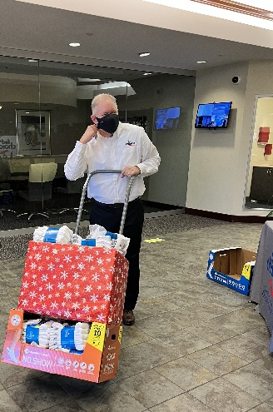
Being a part of the community is important to FedChoice. Serving our members and fulfilling the needs of our local residents are equally critical to our mission as a Credit Union. “We’re always looking for additional ways to help underserved populations. Through community service efforts such as this, and by creating products and services that can assist our members throughout their lives, we strive to improve the wellbeing of our neighbors,” says FedChoice President/CEO, Brett Noll.

####

About FedChoice Federal Credit Union
FedChoice Federal Credit Union was originally chartered in 1935 when a group of Bureau of Internal Revenue (aka IRS) employees decided to establish a credit union to meet their financial needs. Since then, FedChoice has grown stronger each year by serving all federal employees, retirees, and their immediate family and household members in the Washington DC, Baltimore and Philadelphia metro areas. With access to over 60,000 surcharge-free ATMs, over 5,000 CO-OP Shared Branches, plus online and mobile banking, members may access their accounts 24/7/365. FedChoice has over 23,000 members and $435 million in assets.

About So Others Can Keep Striding

Damon Jones, the founder of SOCKS, volunteered to spend the night in a homeless shelter on a cold winter night in 2013. To his surprise, the men spent a great deal of time discussing the value of clean, dry socks. They explained the importance of maintaining healthy feet as they are the primary means of transportation from one place to another. The idea for S.O.C.K.S. came to him in a vision while he slept at the shelter. He is pursuing the vision with tenacity and hitting the streets armed with socks to give away.

