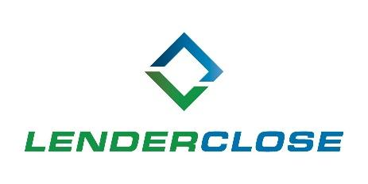

MEDIA CONTACTS:
NEWS RELEASE
Charlyne H. McWilliams/Ayesha Jamil
301.933.5567/678.781.7230
charlyne@williammills.com / ayesha@williammills.com
LenderClose Hires Industry Veteran to Lead Engineering, Expands Tech Team
Fintech firm invests in internal efforts to forge industry improvements in real estate lending
DES MOINES, May 6, 2021 – LenderClose, a real estate and home equity lending technology platform, has hired industry veteran Felix Dominguez to continue the expansion of its engineering division and has added seven additional team members to its technology department. The additions showcase the company’s commitment to streamlining and enhancing the real estate and home equity lending process through automation.

As head of engineering, Dominguez will take on a mentorship role to key engineering personnel, constantly promoting the growth of their professional skills and supporting the vision, design, and strategy of the systems and platforms.

Before joining LenderClose, Dominguez was an IT architect and director of technology at Equifax. He has extensive technical experience and is skilled in providing process improvement solutions. Most notably, Dominguez saved the company $100,000 a year by moving a platform in its verification services division to an Equifax data center. LenderClose is investing in talent such as Dominguez to continue the push to provide sophisticated technology to the industry.

“At LenderClose we aren’t approaching hiring with a ‘butts in seats’ outlook. Rather, we are hiring people like Felix, who are passionate about innovation and change in financial institutions,” said Martina Schubert, CTO of LenderClose. “We want to put smart, talented people in an environment that doesn’t limit their ability or willingness to bring forth new solutions. No one person can corner the market on great ideas, and we are excited to welcome all of our new team members.”

In addition to Dominguez LenderClose also added seven additional hires to the team; Priya Balakrishnan QA engineer; Tracy Hodson, delivery lead; Guy Sinarinzi-Hay, QA engineer; Peter Leap, business intelligence analyst; Aidan Kelderman, technical specialist; Wendy Bear, cyber security manager and Ryan Javelosa, product designer. The growth in LenderClose’s technology team is due to the recent completion of its Series B funding round of $10 million in new capital.

“We are always asking ‘what’s next?’ and with a rapidly growing tech team we have an influx of many great ideas and forward-thinking people.” said Dominguez. “It’s exciting to look around and see so many people pushing the envelope and dedicating themselves to providing the absolute best user experience in this industry.”

About LenderClose, Inc.
LenderClose is a technology-focused home equity and real estate lending platform which injects speed and efficiencies into the lending process, greatly enhancing the borrowing experience. Based in Des Moines, Iowa, the rapidly growing financial technology company is focused on providing credit unions and community banks innovative lending solutions and automated workflows. To learn more, visit lenderclose.com or follow us on LinkedIn or Twitter.

###

