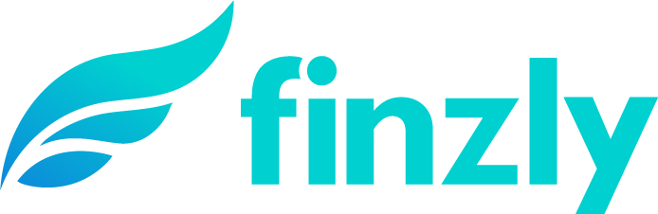
MEDIA CONTACT:
Augusta Bauknight
augusta@williammills.com
678-781-7214

ICBA Bancard and Finzly Partner to Offer Instant Payments

Finzly's core-agnostic payment solution to enable community banks to offer instant payments to their customers

CHARLOTTE, N.C. – July 12, 2021 – Finzly, a fintech provider of modern banking applications for payments, foreign exchange, trade finance and digital account opening, today announced a new partnership with ICBA Bancard, the payments services subsidiary of The Independent Community Bankers of America (ICBA), to facilitate instant payments via Finzly’s Payment Galaxy, a payment hub for improved convenience, cash flow and efficiency for community banks and their customers. Finzly was a fintech participant in ICBA’s 2020 ThinkTECH Accelerator program.

“The rise in digital and contactless payments, fueled by the pandemic, has heighted demand for faster payments,” ICBA Bancard President and CEO Tina Giorgio said. “Through this collaboration, ICBA Bancard is helping community banks deliver payments when and where customers want while streamlining their payment processes for additional value and distinction in the market.”

Payment Galaxy enables the provision of existing payment services like ACH and wires, alongside the new instant payment rails, including The Clearinghouse’s RTP® and when available, FedNowSM using a single, core agnostic, interface.

Finzly's instant payment solution takes the complexity out of instant payments and can be up and running in as little as three months. The payments hub features:
- Preloaded connections to the Fed and The Clearing House for instant payments
- Built-in compliance features, powerful audit trails and meaningful dashboards
- Bulk payment service to pay in real-time or future date scheduling
- A secure system for payments and messages for fraud management

“We are very excited to partner with ICBA Bancard and are eager to see more community banks pursuing the road to innovation through smarter payments transformation,” Finzly Founder and CEO Booshan Rengachari said. “Finzly’s payments hub not only helps banks stay relevant in today’s fast-paced market, but also helps future-proof their payment infrastructure.”

About ICBA Bancard
ICBA Bancard® is the wholly owned payment services subsidiary of the Independent Community Bankers of America. ICBA Bancard’s community bank issuers generated nearly $32 billion in sales volume in 2020 and are ranked collectively as the 24th largest credit card portfolio and 10th largest debit portfolio in the United States. ICBA Bancard enables thousands of community banks to provide competitive credit card, debit card, and payment processing solutions. The company also provides exclusive services to issuers including its Fraud Loss Protection Plan, marketing support, and product education. For more information, visit www.icbabancard.org.

About Finzly
Finzly connects financial institutions with customers through a modern digital banking experience and an efficient, real-time payment services hub. Freeing financial institutions from core system limitations, Finzly’s open, cloud-based bank operating system, BankOS, enables transformation and innovation at the speed of fintech. With freedom to adopt solutions from Finzly and third parties of choice, financial institutions can implement apps in three simple steps – subscribe, try and launch. Serving customers across North America, Finzly has been modernizing international banking and treasury management solutions since 2012. For more information, visit www.finzly.com.

###

