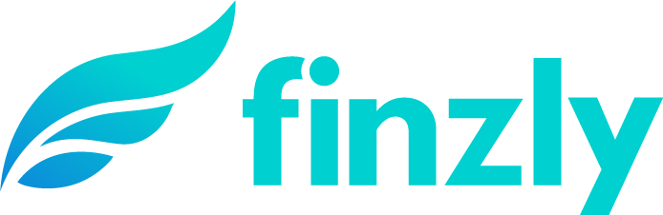
MEDIA CONTACT:
Augusta Bauknight
augusta@williammills.com
678-781-7214

Finzly Launches Interest Rate Derivatives App Within BankOS

Finzly SWAP STAR app enables banks to run an efficient interest rate hedging and hedge accounting program

CHARLOTTE, N.C. – Feb. 16, 2021 – Finzly, a fintech provider of modern banking applications for payments, foreign exchange, trade finance and digital account opening, announced today the launch of SWAP STAR, a state-of-the-art, end-to-end, sales, trading and post-trade processing system for interest rate derivatives.

SWAP STAR is available as an app within Finzly’s open, cloud-based bank operating system, BankOS, and is hosted in a secure SSAE-certiﬁed cloud to provide security, real-time monitoring, automated upgrades, auto-scalability and 99.99% availability. SWAP STAR fully integrates with the banks’ core platform, streamlining the pricing, booking and servicing of customers’ interest rate swaps via a single application.

With SWAR STAR, financial institutions can manage the interest rate risk of their loan portfolio and help their corporate or real-estate borrowers hedge the interest rate risk of their loans. SWAP STAR manages the complete life cycle of the swap, including sales, execution, settlements, resets, reporting, GAAP/IFRS accounting and compliance. Additionally, the cloud hosted platform delivers automated updates to adhere to the latest industry compliance and regulations.

With multiple corporate and treasury solutions available from Finzly through one single integration to the core via BankOS, banks can start with any one solution, such as foreign exchange, trade finance, interest rate swaps or payment hub, and add other solutions later using Finzly’s “plug and play” model. While many solutions take months or even years to implement, BankOS enables FIs to launch any new product or program in a matter of days, saving time and cost while giving banks the power and freedom to innovate without any limitations.

“Finzly’s mission is to help banks better compete in the marketplace by offering services and capabilities on par with, and even exceeding, those of much larger institutions,” said Booshan Rengachari, founder and CEO, Finzly. “BankOS is a revolutionary platform that transforms banking and democratizes access to state-of-the-art technology for financial institutions of any size. SWAP STAR is a ‘big bank’ platform available at an affordable cost for regional and community banks, helping to increase their non-interest income without giving them away.”

The platform also offers Expert Advisory Services, available through Finzly’s partnership with Derivative Logic, an independent hedge advisory firm combining derivative market expertise with proven hedge structuring and execution capabilities in interest rate and currency derivatives.

About Finzly
Finzly connects financial institutions with customers through a modern digital experience and an efficient, real-time payment services hub. Freeing financial institutions from core system limitations, Finzly’s open, cloud-based bank operating system, BankOS, enables transformation and innovation at the speed of fintech. With the freedom to adopt solutions from Finzly and third parties of choice, financial institutions can implement apps in three simple steps – subscribe, try and launch. Serving customers across North America, Finzly has been modernizing international banking and treasury management solutions since 2012. For more information, visit www.finzly.com.

###

