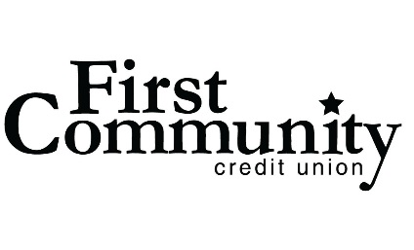
Contact: Laura Alfeldt, Marketing
T: 636-537-4462
lalfeldt@firstcommunity.com

FOR IMMEDIATE RELEASE
First Community Named Best-in-State Missouri
Chesterfield, MO (July 8, 2021) First Community has once again been named Best in State in Missouri on the Forbes list of America’s Best-In-State Credit Unions 2021. This prestigious award is presented by Forbes and Statista Inc., the world-leading statistics portal and industry ranking provider. The awards list was announced on June 24th, 2021 and can currently be viewed on the Forbes website.
Forbes and Statista identified America’s Best-In-State Credit Unions 2021 based on an independent survey of approximately 25,000 US consumers who were asked to rate credit unions at which they have or previously have had checking accounts. Participants made recommendations regarding overall satisfaction; they also assessed banks in the following areas: Trust, Terms & Conditions, Branch Services, Digital Services, Customer Service, and Financial Advice.
“We know this past year people had to make hard choices with their finances, so we are so honored to still be one of the top financial institutions in the region. With almost 90 years of experience, we believe we have always provided excellent member service, and we will continue to uphold our end of the bargain when it comes to superior service and top products.” said President and CEO, Glenn D. Barks.
The past year has proven to be a successful one for First Community as they were also selected for St. Louis Magazine’s A List Awards for “Top Mortgage Provider” as well as one of the St. Louis Business Journal’s “Top 10 Largest Mortgage Lenders” in the region. First Community was also awarded one of the Best Places to work in the St. Louis Post Dispatch, which is voted upon by its employees.
About First Community:
First Community Credit Union has been operating for over 85 years and serves over 350,000 members. First Community is in the top 100 credit unions in the nation. Its mission is to provide quality products and affordable financial services. It serves all persons living and working in the communities of St. Louis County, St. Louis City, Franklin County, Jefferson County, St. Charles County, Warren County, and the Illinois counties of Madison, Monroe and St. Clair.





