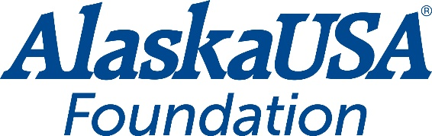

FOR IMMEDIATE RELEASE
June 14, 2021

Alaska USA Foundation Donates to Nonprofit Providing Support to Military and Veterans
Operation Homefront Receives $20,000

ANCHORAGE, Alaska — The Alaska USA Foundation has made it a priority to assist nonprofit organizations who provide needs-based services and in particular, services to veterans and military personnel and their family. In support of this, a $20,000 donation was made to Operation Homefront’s Critical Financial Assistance Program. These funds will be allocated equally in Alaska, Arizona, California and Washington so Operation Homefront can provide direct assistance to military families in need.

For more than 15 years, Operation Homefront has provided programs that offer: Relief (through critical financial assistance and transitional housing programs), Resiliency (through permanent housing and caregiver support services) and Recurring Family Support programs and services throughout the year that help military families overcome the short-term bumps in the road, so they don’t become long-term chronic problems.

“The Alaska USA Foundation is pleased to partner with Operation Homefront and assist in the efforts to provide services that allow our military personnel a stable and secure homelife. By partnering with Operation Homefront, we are providing servicemembers and their families the assistance they need as they are called to duty within the military or transitioning back to civilian life,” said Alaska USA Foundation Executive Director Dan McCue.

More About Alaska USA Foundation
For more than fifteen years, the Alaska USA Foundation has supported 501(c)(3) charitable organizations that provide needs-based services to children, veterans, and active duty members of the military and their families. Since its inception, the Foundation has distributed more than $2.5 million to these organizations and is honored to assist those that provide direct services in support of its mission. Additional information about the Alaska USA Foundation is available at alaskausafoundation.org.

###

Media Contact
Dan McCue
Executive Director
Alaska USA Foundation
907-786-2807
D.McCue@alaskausa.org

