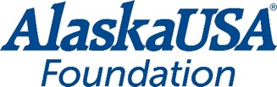
FOR IMMEDIATE RELEASE
May 25, 2021

Alaska USA Foundation donates $92,500 to local nonprofits in Alaska and Arizona

Anchorage, Alaska – The Alaska USA Foundation donated a total of $92,500 to local nonprofit organizations in Alaska and Arizona, working hard to support children, veterans and active-duty military personnel and their families.

$65,000 was donated to Armed Services YMCA of Alaska in support of their efforts to provide ongoing services to military personnel and their families as well as providing funding that will allow them to provide opportunities for brave young men and women of the United States Armed Services to attend a fishing tournament.

$10,000 was donated to Arizona Housing Coalition in support of the Arizona Veterans StandDown Alliance to help homeless veterans access vital medical, metal health and substance abuse services.

$10,000 was donated to Phoenix Children’s Hospital Foundation to support their services and assist them in remaining one of the nation’s leading pediatric hospitals.

$7,500 was donated to Alaska Legal Services Corporation in support of the critical legal services they provide to veterans and active-duty members of the armed forces.

“The Alaska USA Foundation is proud of the impact we can have on local nonprofit organizations in our communities,” said Dan McCue, Executive Director, Alaska USA Foundation. “These organizations help provide much needed services in the communities we serve. We are honored to help these organizations on an ongoing basis to fulfill their worthy missions.”

More About Alaska USA Foundation

For more than fifteen years, the Alaska USA Foundation has supported 501(c)(3) charitable organizations that provide needs-based services to children, veterans, and active-duty members of the military and their families. Since its inception, the Foundation has distributed more than $2.5 million to these organizations and is honored to assist those that provide direct services in support of its mission. Additional information about the Alaska USA Foundation is available at www.alaskausafoundation.org.
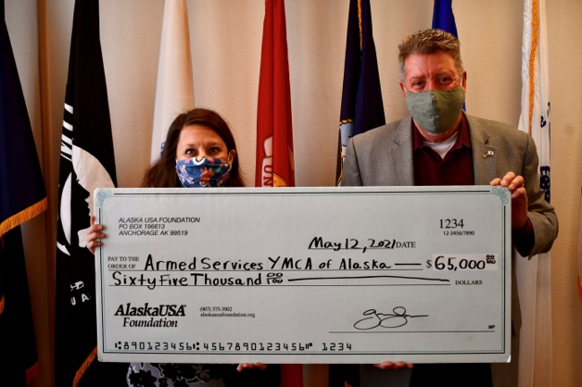
Photo: Alaska USA Foundation donates to ASYMCA Alaska.
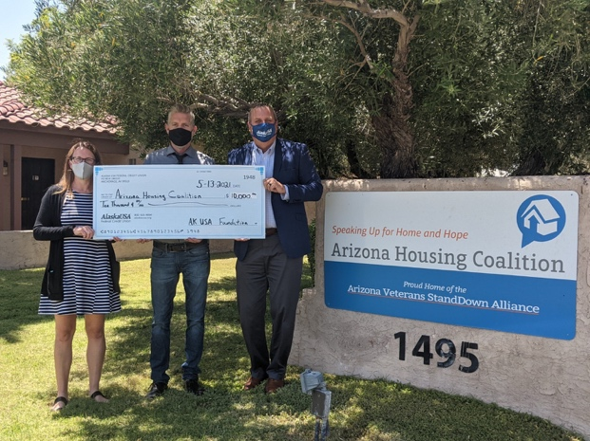
Photo: Alaska USA Foundation donates to Arizona Housing Coalition.
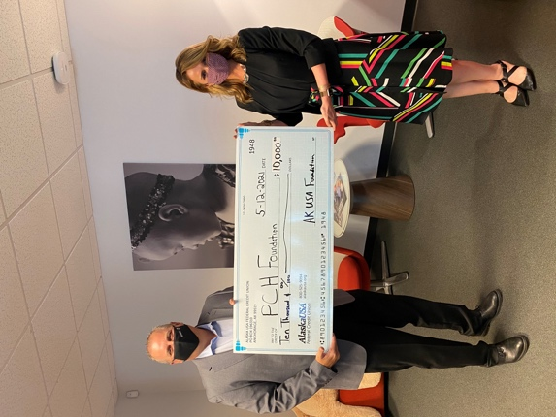
Photo: Alaska USA Foundation donates to Phoenix Children’s Hospital.
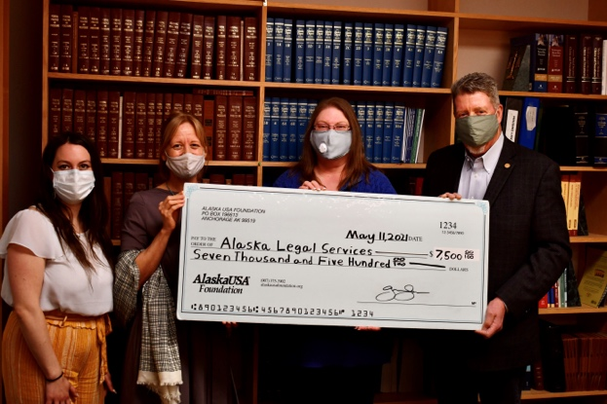
Photo: Alaska USA Foundation donates to Alaska Legal Services.

###

Media Contact
Dan McCue
Executive Director
Alaska USA Foundation
907-786-2807
D.McCue@alaskausa.org

