PRESS RELEASE
For immediate release
August 18, 2021

Frontwave Credit Union Named Credit Union of the Year by U.S. Department of the Navy
OCEANSIDE, CA – Frontwave Credit Union was awarded Credit Union of the Year for 2020 by the Department of the Navy on August 10, 2021, at the Defense Credit Union Council Annual Conference in Naples, FL.
Presented annually, the award recognizes on-base financial institutions that provide extraordinary service. This year’s award recognized Frontwave for the distinguished service and financial education it provides to Marines, Sailors and civilians aboard Marine Corps Base Camp Pendleton.
“It’s an honor to be recognized once again for our passion for serving the military and our Members’ financial needs,” said Bill Birnie, President/CEO of Frontwave Credit Union. “Frontwave has been serving the Marines, Sailors and civilians aboard Camp Pendleton for nearly 70 years – and our commitment to their financial success remains as strong as ever.”
This is the fifth time in the last seven years that Frontwave has been honored by the Department of the Navy for its service to Marines and Sailors, having won Credit Union of the Year in 2014, 2015, 2016, 2017 and now 2020.
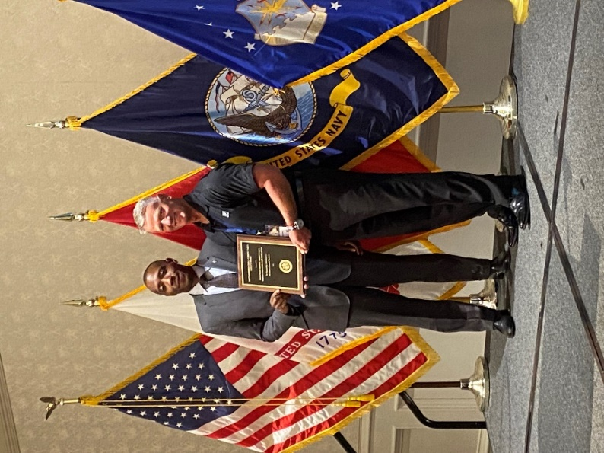
(From left to right) U.S. Marines Corps Asst. Deputy Commandant for Programs and Resources, SES William H. Roberts presented the Credit Union of the Year award to Frontwave Director of Community Development and Chief Warrant Officer (USMC-Ret.) Chip Dykes.
####

About Frontwave Credit Union
Frontwave Credit Union is a member-owned not-for-profit financial institution serving San Diego, Riverside, and San Bernardino Counties. Frontwave Credit Union provides a portfolio of financial products and services including checking and savings accounts, auto loans, mortgage loans, credit cards, home equity loans, and financial planning. Forged in 1952 as Camp Pendleton Federal Credit Union in Oceanside, California, Frontwave has grown from 8 civil service employee members and $40 in assets to over 115,000 members and nearly $1.2 billion in assets. Frontwave Credit Union has been awarded Department of the Navy’s 2020 Best Credit Union of the Year, voted San Diego’s Best Credit Union and Best Mortgage Company in the 2020 San Diego Reader “Best Of” Readers Poll, and is continuously recognized as a best place to work in Southern California, winning the Peter Barron Stark Award for Workplace Excellence again in 2020. To learn more, visit frontwavecu.com.

MEDIA CONTACT:
Amber Gabrenas
Marketing Communications Specialist
Frontwave Credit Union
760.631.8700 x1413
agabrenas@frontwavecu.com

