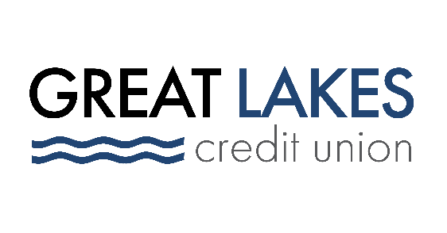

www.glcu.org
FOR IMMEDIATE RELEASE | media@glcu.org  (847) 578-7324
Great Lakes Credit Union Donates More Than 700 Coats to Local Vets

Bannockburn, Ill.– December 7, 2021 – This holiday season, Great Lakes Credit Union (GLCU) is donating 720 coats to local vets in need.

The coats, gathered through GLCU’s annual coat drive, were donated by GLCU members and employees, and collected at GLCU’s 12 branches, GLCU corporate headquarters and the Great Lakes Naval Base.

“Our members and employees have a shared sense of service to the communities in which we live and work,” said Abraham Santiago, Sr. Manager of Community & Financial Development Programs at GLCU. “This large donation of coats, which we were able to collect in just a few weeks’ time, is a powerful reminder of how impactful those shared values can be on our communities.”

The donation will benefit Midwest Veterans Closet, a not for profit establishment in North Chicago, Illinois that provides food, goods, and clothing for US military heroes. All items donated to the foundation are free of charge to veterans; retired and active duty service members; and their families.

GLCU welcomes its members, employees and residents of local communities – even those who aren’t GLCU members – to get involved in giving back. To learn more about how you can get involved with GLCU’s community events and volunteer opportunities, visit https://www.glcu.org/about-us/get-involved/.

About Great Lakes Credit Union
Founded in 1938 and headquartered in Northern Illinois, GLCU is committed to financial empowerment for you. As a not-for-profit financial cooperative with over $1 billion in assets, GLCU is proud to serve more than 80,000 members in the Chicagoland and surrounding areas. Learn more about GLCU’s accounts, educational initiatives and community development programs at glcu.org

