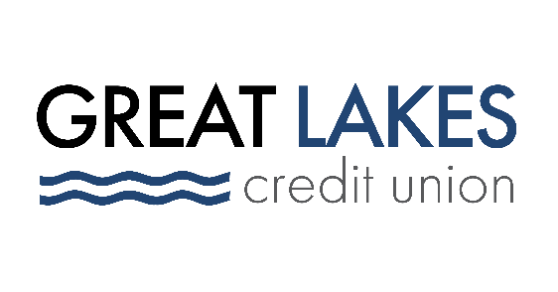

FOR IMMEDIATE RELEASE

Great Lakes Credit Union Launches New Business Services

Bannockburn (IL) – August 3, 2021 – Great Lakes Credit Union (GLCU) is excited to announce the relaunch of their Business Services. GLCU is now offering a comprehensive suite of business products and services, including new and improved Business Checking and Business Savings accounts. By relaunching and revamping the accounts, GLCU will be able to better serve its members and the local business communities.

“This is a very exciting time for GLCU,” says Senior Commercial Lender Brian Gawin. “We recognize there is significant demand for products and services that directly support the business banking marketplace. However, these needs are often not adequately addressed by other financial institutions that are focused on serving bigger customers. As a community based organization, we truly value our small business relationships and we’re committed to providing customized solutions or our business members”

To assist businesses with managing unexpected expenses, GLCU is now offering Microlending. This service, aimed at helping businesses in the community flourish and continue to grow, will include unsecured loans as well as auto loans for company vehicles. In addition to Microlending, GLCU will be able to provide traditional business loans as well as additional financing through our access to various SBA loan programs.

“As a credit union, we are all about people helping people – small business owners included. And as a local business ourselves, we prioritize investing in the communities we serve,” says CEO Steve Bugg. “That investment keeps those communities thriving, so they remain a place that our employees and members love to call home.”

To get started on Business Banking with GLCU, call 800-982-7850, or visit any GLCU branch. https://www.glcu.org/24-7-access/locations/

About Great Lakes Credit Union
Founded in 1938, GLCU continues to be a growing staple in our communities. As a not-for-profit financial cooperative, chartered by the State of Illinois and insured by the NCUA, we are guided by a dedicated volunteer Board of Directors and seasoned leadership team and are proud to serve more than 80,000 members with over $1 billion in assets. We are headquartered in Northern Illinois and have 12 branch locations and more than 170 fee-free ATMs locally. GLCU also belongs to the CO-OP Shared Branching Network. Members can access accounts nationwide at over 5,600 institutions with thousands of locations in 50 states, and at any of their 30,000 surcharge‐free CO‐OP ATMs. All 200+ employee-owners pride ourselves on building lifelong relationships with our member-owners and providing them with financial education during all life stages. Learn more at glcu.org

Media Contact:
media@glcu.org
(847) 578-7324
www.glcu.org

