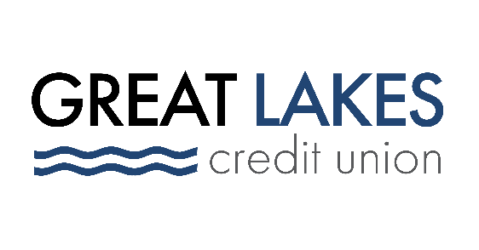

www.glcu.org
FOR IMMEDIATE RELEASE | media@glcu.org  (847) 578-7324
Great Lakes Credit Union Wins CUES’ First Ever “DEI: Catalyst for Change” Award

Bannockburn, Ill. – Oct. 26, 2021 – Great Lakes Credit Union is honored to win the first-ever “DEI: Catalyst for Change” Award, presented by CUES on October 21, 2021.

The award – which recognizes credit unions that have demonstrated sustained support for advancing diversity, equity and inclusion in their workplace, industry and communities – was given to GLCU based on the work the organization has done to support underserved communities and foster inclusion in the workplace.

“At GLCU, we truly believe that underserved and underbanked individuals deserve the same access to financial and other systems as those who are more well off, and the work we do in our communities and within GLCU to foster inclusion reflects that belief,” said Steve Bugg, President and CEO.

As a credit union, GLCU returns profits to its members in the form of competitive loan rates and savings dividends. But the organization also takes extra steps to ensure that a sizeable share of its profits are returned to the communities it serves through strategic partnerships with local organizations; grants and donations to causes that align with GLCUs mission of empowering others; and offering housing and financial counseling to both members and non-members through its HUD-approved counseling program.

“We want to ensure that that residents in our communities are empowered not just to live the greatest version of their life, but also to reinvest in their own communities. This creates a positive cycle of change that has long-lasting effects,” said Bugg.

In addition to its ongoing community drives, sponsorships and events, in 2021 GLCU administered assistance to Lake County-based small businesses through the federal Paycheck Protection Program; partnered with the Lake County Community Foundation to help launch their Small Business Growth Initiative to support women and BIPOC-owned businesses; and partnered with Habitat Chicago to conduct financial and housing counseling sessions for participants in their Affordable Homeownership Program.

About Great Lakes Credit Union
Founded in 1938 and headquartered in Northern Illinois, GLCU is committed to financial empowerment for you. As a not-for-profit financial cooperative with over $1 billion in assets, GLCU is proud to serve more than 80,000 members in the Chicagoland and surrounding areas. Learn more about GLCU’s accounts, educational initiatives and community development programs at glcu.org

