Toni Nichols
Texas Trust Credit Union
972-595-1017
tnichols@texastrustcu.org

Kristine Tanzillo
Dux Public Relations
903-865-1078
kristine@duxpr.com

Press Contacts:

Texas Trust Credit Union Opens New Branch
at Fish Creek Preserve in Grand Prairie

Arlington, Texas – Dec. 6, 2021 – Texas Trust Credit Union officially opened the doors of its newest branch at Fish Creek Preserve at South Carrier Parkway and I-20. This is Texas Trust’s third branch in Grand Prairie and 20th in the state. This is also the first new branch the credit union has built from the ground up since 2005.

Construction of the 4,280-square-foot building began in February. Financial services at the branch include checking and deposit accounts, car and recreational vehicle loans, low-interest credit cards, home loans for new purchases and refinancing, insurance, and retirement planning. The branch is managed by Sierra Garzes, who has served the community at all of Texas Trust’s Grand Prairie locations since 2014.

The branch has three drive-thru lanes, which will offer two-way video for members to communicate with branch staff inside the credit union. This is the first Texas Trust branch to use video in the drive thru instead of the traditional drive up window. The branch also offers a community room with capacity for up to 30 people, a coin counting machine, safe deposit boxes, a partner office, and convertible outdoor space for small events.

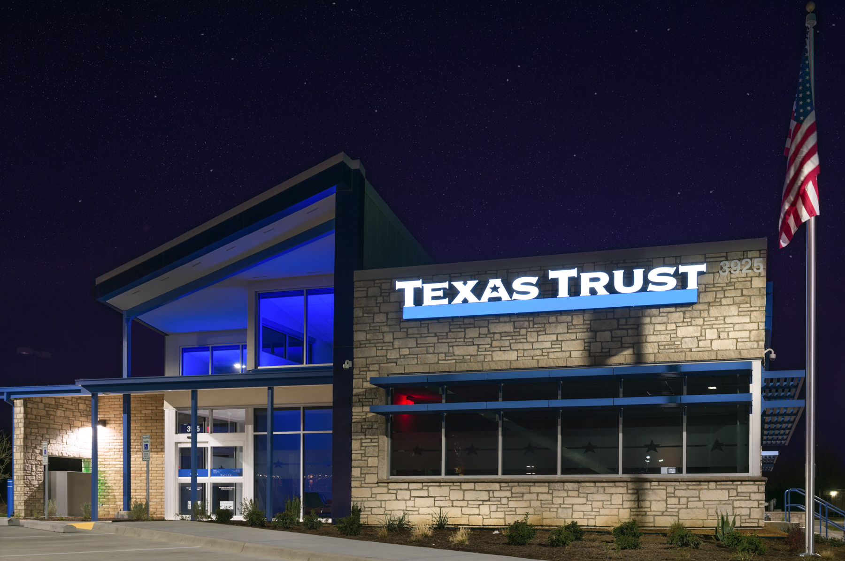

“This is a perfect location for a large number of our members who live within three to five miles of the Fish Creek Preserve,” said Jim Minge, CEO of Texas Trust Credit Union. “The personal touch our members receive at the branch is what makes us different from other financial institutions.”

Minge added, “We know our members value the in person face-to-face relationships with our branch staff, which is why we added this strategically located branch.”

Branch hours are Monday through Thursday from 9 a.m. to 5 p.m., Friday from 9 a.m. to 6 p.m., and Saturday from 9 a.m. to 2 p.m. Drive-thru lanes will be open 8 a.m. to 6 p.m. Monday through Friday and 9 a.m. to 2 p.m. Saturday.

The exterior of the building features a limestone façade and adobe brick with weathered wood accents highlighted with metal and glass. The metal and glass will glow with a “Texas Trust Blue” light during the night. The interior features bright and polished aesthetics warmed with wood accents.

Keeley Construction of St. Louis and Oculus Inc., designed and managed the building project.

High resolution images of the branch can be downloaded here.

About Keeley Construction
Keeley Construction provides cutting edge turnkey services to financial institutions throughout the United States. Keeley Construction was founded in 1976 as a family-owned paving company. Over four decades and 850+ Keeley’ns later, Keeley Construction has become a nationally-known, full-service construction company with four diverse business groups – Civil, Paving, Building, and Industrial. Keeley Building is nationally recognized for its impact on communities, positively changing the way people shop, work, learn, engage, and evolve. Keeley Building’s expertise allows them to accommodate a wide variety of projects, with a customer-centric nature that is redefining how modern construction ventures are planned and executed.

About Oculus Inc.
Oculus Inc. delivers comprehensive architecture, interior design, planning and move management services with a driving aesthetic to Connect | Shape | Move people, experiences, sensibilities and spaces. Oculus creates high-performance design that supports change and promotes value for clients in the commercial, education, government, healthcare, hospitality, retail, restaurant and workplace industries. Oculus has offices in St. Louis, Dallas and Portland, Ore., is WBE-certified and is regularly cited in top industry rankings for architecture and design.

About Texas Trust Credit Union
Texas Trust Credit Union has been helping build brighter financial futures since its modest beginning in 1936. Today, the full-service credit union serves more than 120,000 members. With assets of more than $1.6 billion, Texas Trust is the 6th largest credit union in North Texas and the 17th largest in Texas. With a focus on the community, Texas Trust is creating a legacy of giving through generous financial donations that support local school programs and activities, non-profit organizations, and student scholarships; and by providing volunteer resources through its Community Unity team, which supports scores of charitable events each year. For more information, visit TexasTrustCU.org or follow us on Facebook at facebook.com/texastrustcu or Twitter at @texastrustcu.

###

