PRESS RELEASE
For immediate release
July 15, 2021

DCUC Selects Retired Frontwave Director George Hoagland for Hall of Honor
OCEANSIDE, CA – The Defense Credit Union Council (DCUC) has selected Lt. Col. USMC (Ret.) George Hoagland for induction into its prestigious Hall of Honor. Hoagland, the inaugural recipient of the Frontwave Credit Union Lifetime Achievement Award, retired from the Frontwave Board of Directors in March of 2021 after an exemplary 53 years of service to the credit union.
Established in 2000, the coveted DCUC Hall of Honor award highlights the outstanding accomplishments of leaders, volunteers, management and staff whose untiring efforts and endless support have made a significant and most noteworthy difference in the defense credit union community.
Hoagland’s service to the defense credit union movement began during his service in the Marine Corps, when he was assigned by the 29 Palms base commander to assist in saving the failing 29 Palms Federal Credit Union, which eventually merged with what is now known as Frontwave Credit Union. During his tenure on the Board of Directors, Hoagland served twice as Chairman of the Board, spent numerous years as Vice Chairman, and was a member of every Board committee. He played key roles in three mergers, helping the credit union grow from an asset size of under $89,000 back in 1969 to over $1 billion today.
Hoagland has provided selfless assistance to Marines, sailors, and their families for more than half a century, all the while guiding the steady rise of Frontwave to its current place as a highly respected, major financial institution in Southern California.
“George has been a consistent pillar of caring, hands-on leadership in both our military and civilian communities,” said Bill Birnie, President/CEO of Frontwave Credit Union. “He has put his heart and soul into the success of the credit union and its Members, and truly exemplifies the Council’s values and philosophy of ‘Serving Those Who Serve Our Country.’ I can think of no one more deserving of this honor than George.”
Hoagland will be officially inducted into the DCUC Hall of Honor at 2021 DCUC Annual Conference on August 12 in Naples, FL.
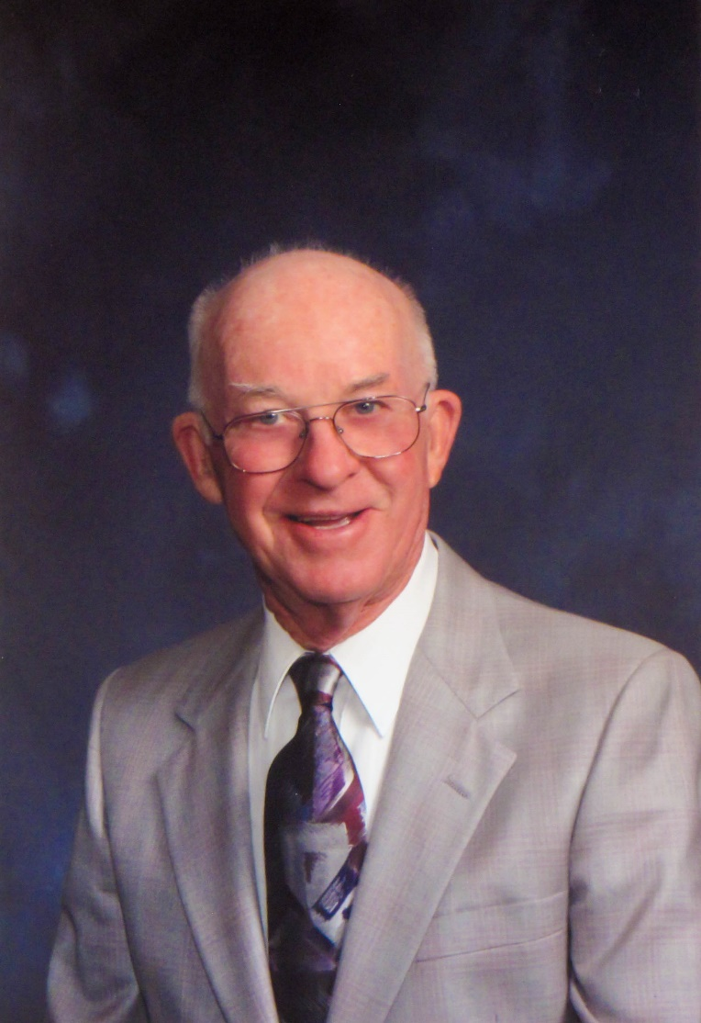
Lt. Col. USMC (Ret.) George Hoagland
####

About Frontwave Credit Union
Frontwave Credit Union is a member-owned not-for-profit financial institution serving San Diego, Riverside, and San Bernardino Counties. Frontwave Credit Union provides a portfolio of financial products and services including checking and savings accounts, auto loans, mortgage loans, credit cards, home equity loans, and financial planning. Forged in 1952 as Camp Pendleton Federal Credit Union in Oceanside, California, Frontwave has grown from 8 civil service employee members and $40 in assets to over 115,000 members and nearly $1.2 billion in assets. Frontwave Credit Union was voted San Diego’s Best Credit Union and Best Mortgage Company in the 2020 San Diego Reader “Best Of” Readers Poll, and is continuously recognized as a best place to work in Southern California, winning the Peter Barron Stark Award for Workplace Excellence again in 2020. To learn more, visit frontwavecu.com.

MEDIA CONTACT:
Amber Gabrenas
Marketing Communications Specialist
Frontwave Credit Union
760.631.8700 x1413
agabrenas@frontwavecu.com

