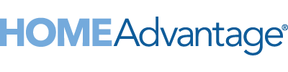
Wings Financial celebrates saving members $2 million through the HomeAdvantage program

December 20, 2021﻿﻿

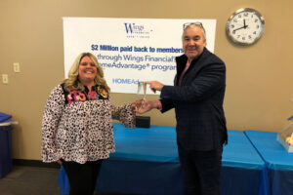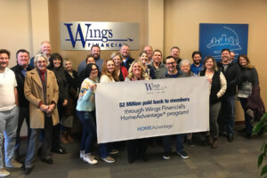
Left Image:
Kristin Saul – Real Estate Business Development Manager, Wings Financial
Greg Notvedt – National Account Executive, HomeAdvantage
To save a high-res file of the photo, click on the image above to open the full-size photo and then right-click to save the file to your computer.

SCOTTSDALE, AZ – Minnesota-based Wings Financial Credit Union has reached the threshold of saving its credit union members more than $2 million when they buy or sell homes through the HomeAdvantage® platform. Wings Financial was first inducted to the Million Dollar Club in 2019, five years after joining the HomeAdvantage program. It took just two years for Wings Financial members to earn a second million dollars in Cash Rewards. Just 13 credit unions across the United States are part of the exclusive HomeAdvantage Million Dollar Club.

“Wings Financial has played an important role in helping many people achieve their homeownership goals,” said Herb Behrens, CEO of HomeAdvantage. “Their accelerated pace to giving back a second million dollars to their members is a testament to the dedication of their mortgage team and their robust homebuyer education programs.”

HomeAdvantage’s signature real estate marketing platform features frontend tools that attract members at the beginning of their home-buying journey. Backend systems and personal touchpoints nurture them until they are ready to transact. One of those critical touchpoints is the connection to a HomeAdvantage-certified real estate agent who is trained to keep credit union financing top-of-mind. HomeAdvantage recently announced a national expansion. Credit union members can now connect with certified real estate agents and earn HomeAdvantage Cash Rewards in nearly every state and metro area in the U.S.

With more than 320,000 members and $7.5 billion in assets, Wings Financial members earn an average Cash Reward of $1,861 per real estate transaction. To date, nearly $60 million in HomeAdvantage Cash Rewards has been given back to credit union members across the United States.

Wings Financial’s success with HomeAdvantage is due in part to their commitment to homebuyer and homeseller education. In-person seminars and online webinars are held multiple times per month to provide valuable information to members and bring awareness to HomeAdvantage and the credit union’s purchase mortgage products.

In the last 12 months, more than 1,200 Wings Financial members were registered into the HomeAdvantage program resulting in 250 closings. Of those registrations, 90% were not already working with an agent and 75% were not yet pre-qualified for a mortgage loan.

“HomeAdvantage has been a great partner for both Wings Financial and our members over the last seven years,” says Norm Creveling, Chief Lending Officer at Wings Financial Credit Union. “As the cost of housing continues to rise, Wings Financial is committed to providing our members with the buying power they need to give flight to their financial dreams. Our partnership with HomeAdvantage helps do just that, giving our members the tools, resources and Cash Rewards they need to make their dreams a reality.”

To date, the thirteen credit unions to earn a spot in the HomeAdvantage Million Dollar Club are Affinity Plus Federal Credit Union, Apple Federal Credit Union, Bank-Fund Staff Federal Credit Union, BCU, FAIRWINDS Credit Union, Northwest Federal Credit Union, Partners Federal Credit Union, Redwood Credit Union, SECU, State Department Federal Credit Union, Tower Federal Credit Union, Wings Financial Credit Union and Wright-Patt Credit Union.

ABOUT WINGS FINANCIAL
Wings Financial Credit Union is Minnesota’s largest credit union and one of the top credit unions nationally, with $7.5 billion in assets and over 320,000 members. In 2021, Wings was named one of the top ten credit unions nationally by Gobankingrates.com, as well as a Star Tribune top workplace for the ninth consecutive year. Wings Financial operates 26 branch locations throughout the state of Minnesota, plus offices in Atlanta, Detroit, Orlando, and Seattle. Founded in 1938, Wings’ membership has grown to include anyone who lives or works in 34 Minnesota and Wisconsin counties including the Minneapolis–St. Paul metro area, the metropolitan areas of Atlanta, Detroit, Seattle and Orlando and the aviation industry nationwide. To learn more, visit www.wingsfinancial.com

﻿ABOUT HOMEADVANTAGE
Formerly CU Realty Services, HomeAdvantage provides real estate services to credit unions across the nation, helping them increase their purchase mortgage business while saving their members money when they buy or sell a home. The company’s turnkey real estate marketing platform is currently offered by more than 126 credit union partners and mortgage CUSOs throughout the United States. Credit union members can use the program to search for homes, research neighborhoods, calculate property values, connect to certified real estate agents and save money at closing. When credit unions offer the program, they can attract and nurture more home-buying members, and consequently close more loans. To learn more, please visit www.homeadvantage.com or connect with us on LinkedIn.

# # #

Media Contact
Rachel Brown
rbrown@synergy-pr.com
314.266.7035

