United Federal Credit Union – Press Release
April 20, 2021

Contact: Diana Wake
Phone: (888) 982-1400 ext. 6891
Email: dwake@unitedfcu.com
United Federal Credit Union, 150 Hilltop Road, St. Joseph, Michigan, 49085

United Federal Credit Union Names Harry Grymes Senior Commercial Loan Officer in Hendersonville, North Carolina

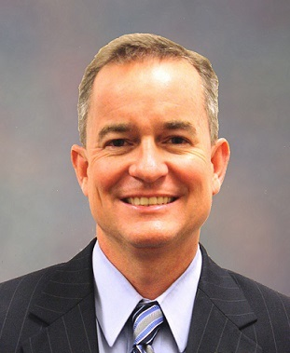
Harry Grymes, Senior Commercial Loan Officer, Hendersonville

HENDERSONVILLE, N.C. – United Federal Credit Union (United) has appointed Harry Grymes to the position of Senior Commercial Loan Officer serving the Hendersonville market.

As a Senior Commercial Loan Officer, Grymes will provide quality business lending expertise through financial counseling and product awareness to credit union Members regarding their business financing needs. He brings more than 21 years of experience in the banking industry to his new role. Prior to joining United, he was a Commercial Portfolio Manager with First Citizens Bank in Hendersonville.

Grymes earned a bachelor of arts degree in Advertising/PR from the University of South Carolina-Columbia and is a graduate of the North Carolina School of Banking at UNC Chapel Hill.
In the community, Grymes is an advocate for United’s community impact efforts supporting organizations such as the Flat Rock Playhouse, the Boys & Girls Club of Henderson County, and other local non-profit groups.

____________
About United
United Federal Credit Union has served its Members since 1949 by helping them to build a sound financial future. United consists of more than 179,000 Member/owners worldwide and manages assets in excess of $3.3 billion. Its corporate offices and main branch are in St. Joseph, Mich., with additional branches in Arkansas, Indiana, Michigan, Nevada, North Carolina, and Ohio. Federally insured by NCUA. Equal opportunity lender. Equal housing lender. For more information visit www.unitedfcu.com

# # #

