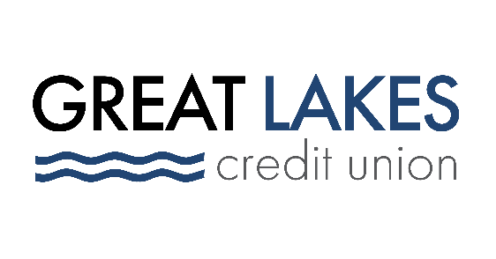

FOR IMMEDIATE RELEASE

Cybersecurity: A Key Ingredient in the Recipe for Safe Holiday Shopping
Great Lakes Credit Union Offers Tips to Keep People’s Money Safe

Bannockburn, IL – Nov. 18, 2021 – As the holiday season rapidly approaches, American consumers prepare for the annual ritual of seasonal gifting for friends and loved ones. With forecasters predicting that retail holiday sales will likely top $1.3 trillion during the November to January timeframe, the threat of fraud and cybercrime will also be dangerously high.

“As the economy continues to strengthen, consumer spending this holiday season is predicted to increase between 7 to 9 percent over last year,” said Elizabeth Osborne, Chief Operations Officer of Great Lakes Credit Union, who oversees operations, technology, and information security for the credit union. “While that’s welcome news for retailers, increased holiday sales also means that there will be greater opportunity for fraud—especially in the area of cybercrime.”

Retail industry experts are also predicting that e-commerce/online sales will grow by 11 to 15 percent, year-over-year, during the 2021 holiday season. This will likely translate into online holiday sales of between $210 billion and $218 billion. Although shoppers will spend more time—and money--online this year, there are several measures that can be taken to lessen their exposure to cybercrime and fraud.

Great Lakes Credit Union is sharing a checklist of the “dos and don’ts” that can make holiday shopping safer and minimize consumers’ exposure to cybercrime:

- Be on the lookout for malicious advertising (“malvertising”). These ads, which fraudsters place on reputable sites using an ad buying network, look real but direct you to a site that can steal your card and other personal information. Rather than clicking on an advertisement, search for the item online and click on the link in the search results (just avoid clicking on results with the word “ad” next to them).
- Whether you’re using a debit card or credit card, don’t save your card information on any online shopping sites, and don’t do your holiday shopping on a public Wi-Fi network. This will minimize the risk of a fraudster gaining access to your information.
- Avoiding use of the same password for multiple websites; hackers will often discover a password and then attempt to use it on multiple sites the consumer has visited. When visiting large, national retail websites, consider resetting passwords prior to holiday shopping. For extra protection, consider using a password manager which can create and encrypt unique, randomly generated passwords for you to use on different sites.
- Be aware of ‘phishing’ schemes; the holiday season is a favorite time of year for hackers to go phishing, which involves sending an email pretending to be a well-known or familiar company in an attempt to solicit personal/financial information, particularly credit card data. You should never open attachments from unfamiliar or questionable email addresses and be aware that reputable retailers never actively solicit financial data or credit card information
- Be on guard for suspicious, unsecured websites. Watch out for misspelled websites or names similar, yet different, than the real company’s name. Also, check to see if “https” is included in the page’s URL; this is one important element of website security that ensures that the connection between your login and the retailer’s server is secure.

“The holiday season is one of great joy and festivity,” said Osborne. “By taking a few precautions when gift shopping and always being aware of the potential dangers lurking online, consumers can help ensure that their 2021 holiday season is a joyous one.”

About Great Lakes Credit Union
Founded in 1938 and headquartered in Northern Illinois, Great Lakes Credit Union is committed to financial empowerment for its members. As a not-for-profit financial cooperative with over $1 billion in assets, the credit union is proud to serve more than 80,000 members in the Chicagoland and surrounding areas. Learn more about Great Lake Credit Union’s accounts, educational initiatives, and community development programs at www.glcu.org.

###

