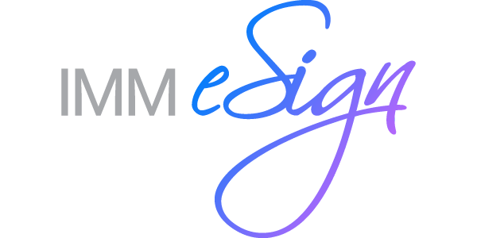
MEDIA CONTACT: FOR IMMEDIATE RELEASE
Anna Stanley
anna@williammills.com
251.517.7857

IMM Elevates Howard Klein to COO, Michael Ball to Senior Vice President of Strategy and Innovation
--Company promotes two key executives to drive future growth and expansion—
RAHWAY, N.J., Jan. 26, 2021 – IMM, the only eSignature provider that specializes in digital transaction solutions exclusively for financial institutions, today announced the promotion of two members of the company’s executive team, Howard Klein and Michael Ball. Klein, formerly vice president of operations, was named the new chief operating officer (COO) and Ball, formerly vice president of markets and strategy, is now senior vice president of strategy and innovation, effective immediately.

Klein joined IMM in 2011 and quickly became a pivotal member of the executive team, focusing on the long-term success of the company’s customers. Under his leadership, IMM has achieved record growth including triple-digit customer growth and record retention rates. In his new role as COO, Klein assumes more oversight and strategic planning responsibilities across IMM’s business operations and corporate infrastructure.

In his new expanded role, Ball will continue to oversee the development and execution of IMM’s marketing and product strategy and will add responsibilities for the company’s sales efforts, customer service initiatives, product innovation, professional services and marketing operations for both the banking and credit union divisions. A 30-year veteran of the financial services industry, Ball was instrumental in accelerating the company’s digital transformation efforts including the expansion into a new vertical market, securing more than 125 new bank customers in less than 24 months.

Powering millions of end-to-end digital transactions each month, IMM eSign seamlessly interfaces with existing business systems to optimize back-office operations and provide a more dynamic and engaging customer experience. The transaction experience is frictionless and easy to use for financial institution employees while maintaining the safety and security for customers to sign documents remotely. IMM is the only eSignature provider that specializes in eSignature and Digital Transaction solutions exclusively for financial institutions.
About IMM
For 24 years, IMM has been the premier provider of eSignature and Digital Transaction solutions designed exclusively for financial institutions. Today, more than 1,300 banks and credit unions use IMM’s eSignature and Digital Transaction Management solutions across the Institution to elevate consumer experiences while streamlining back-office processes in a comprehensive, end-to-end digital processing environment.

For more information, visit www.immonline.com or call 1.800.836.4750. Follow us on LinkedIn, Facebook and Twitter.

