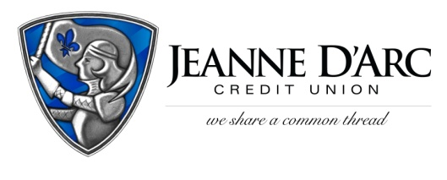

FOR IMMEDIATE RELEASE CONTACT: Robin Lorenzen
November 5, 2021 978-323-3226

Two Jeanne D’Arc Credit Union Young Professionals Honored
LOWELL, MA – On Thursday, October 14, the Greater Lowell Chamber of Commerce hosted their annual meeting and Distinguished Young Professionals Awards. Jeanne D’Arc Credit Union employees Kim Fontaine and Robert Boley were two of the fifteen honored at the event.
Since its inception in 2005, the Distinguished Young Professionals of Greater Lowell has focused on fostering relationships among industry professionals. This allows them to grow their business, meet new contacts, and change the community. In 2015, the Young Professionals merged with the Greater Lowell Chamber of Commerce to bring this networking group to new and exciting heights while still keeping their mission the same.
Kim Fontaine is the Assistant Treasurer, Financial Wellness Manager at Jeanne D’Arc and has been with the company for 15 years. She and her team develop innovative, experiential, and age-specific learning programs for children, teens, and adults in the Lowell area. Kim is a Certified Educator in Personal Finance and recently certified as a Credit Union Financial Counselor. She and her team are out in the community every day helping others make smart financial choices. Kim currently serves on the Project LEARN, Inc. Associate Board, the Greater Lowell Youth Council, and actively volunteers for many organizations throughout the Greater Lowell community.
Robert Boley is the Assistant Vice President of Business Services at Jeanne D’Arc, where he is also a Certified Project Manager. Robert assists Jeanne D’Arc business and community members with planning, launching, and growing their businesses. Robert’s passion is his involvement in the community. He is on several boards and committees including Mill City Grows, Troubled Waters, and the Boys & Girls Club of Lawrence.
“We are so proud to have these two young professionals on our Jeanne D’Arc Team,” said Mark S. Cochran, President, and Chief Executive Officer. “The work we do in the community is so important to us and we are lucky to have Kim and Robert representing us.”

###

About Jeanne D’Arc Credit Union:
Jeanne D’Arc Credit Union was established in 1912 and is a full-service, community-based financial cooperative. Locally owned by 93,000 members with $1.7 billion in assets, Jeanne D’Arc operates eight full-service branches in Lowell, Dracut (2), Tyngsboro, Chelmsford, Methuen and Westford, Massachusetts and Nashua, New Hampshire; high-school branches at Lowell High, Dracut High, and Nashua High School South; a loan center in Lowell; and a mortgage center in Chelmsford.
Kim Fontaine is the Assistant Treasurer, Financial Wellness Manager at Jeanne D’Arc and was named one of The Greater Lowell Chamber of Commerce’s Distinguished Young Professionals.

Robert Boley is the Assistant Vice President of Business Services at Jeanne D’Arc and was named one of The Greater Lowell Chamber of Commerce’s Distinguished Young Professionals.

