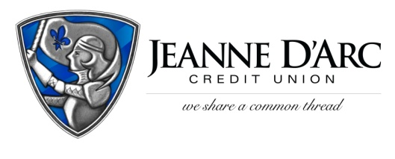

FOR IMMEDIATE RELEASE CONTACT: Robin Lorenzen

WITH PHOTO 978-323-3226

January 14, 2021

***Jeanne D’Arc Credit Union Awards $1,500 to***

***Greater Lawrence Family Health Center***

**LOWELL, MA** – Greater Lawrence Family Health Center is the latest non-profit organization to be awarded a $1,500 donation from Jeanne D’Arc Credit Union’s We Share a Common Thread Foundation, as part of the fourth quarter (October-December) Give-a-Click program.

The Give-a-Click program runs quarterly on the [*We Share a Common Thread Foundation* website](http://www.wsact.com) ([WSACT.com](http://www.wsact.com)). Community members visit the site, learn about the worthy non-profit contestants, and cast their vote for the organization they would like to support. The non-profit with the most votes at the end of the quarter is awarded a $1,500 donation from the Foundation.

The Greater Lawrence Family Health Center (GLFHC) has provided comprehensive primary health care services to underserved residents of the Merrimack Valley since 1980. The GLFHC is focused on improving the health of people and their families in the Merrimack Valley area. Located in Lawrence, Massachusetts, GLFHC has eight clinical locations providing care to more than 62,000 patients a year. Their mission is to improve and maintain the health of individuals and families in the Merrimack Valley by providing a network of high quality, comprehensive health care services and by training health care professionals to respond to the needs of a culturally diverse population.

“The Greater Lawrence Family Health Center provides an invaluable service helping people in the underserved communities of the Merrimack Valley,” said Mark S. Cochran, President and Chief Executive Officer at Jeanne D’Arc Credit Union. “We are glad we can provide exposure for all of our Give A Click nominees and always happy to award the winner with the financial contribution.”

"We always look for the opportunity to partner with Jeanne D'Arc Credit Union and were excited to have been included in their We Share a Common Thread Foundation’s Give-a-Click program,” said David Hall, Associate Vice President of External Relations at Greater Lawrence Family Health Center.

This $1,500 award will facilitate GLFHC to help meet the needs of underserved communities in the region and move closer to achieving its mission in providing health care services to the Merrimack Valley. The awarded funds will be used to help renovate and expand GLFHC’s Lawrence clinic, which is their largest clinic and accounts for 33% of their annual patient visits.

Please visit [www.glfhc.org](http://www.glfhc.org) to learn more.

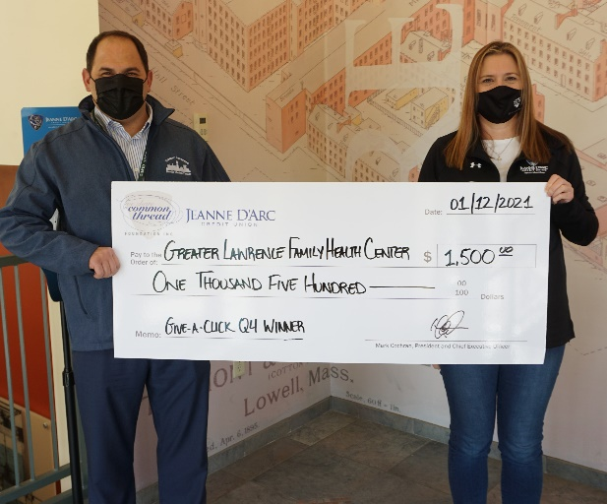

**Photo cutline:** David Hall (left), Associate Vice President of External Relations at Greater Lawrence Family Health Center, alongside Alison Hughes (right), Assistant Treasurer, Community Engagement Officer at Jeanne D’Arc Credit Union, holds the award check for the We Share a Common Thread Foundation’s quarterly Give-a-Click program from Jeanne D’Arc Credit Union. The organization received a $1,500 donation as the winning prize.

###

**About Jeanne D’Arc Credit Union:**

Jeanne D’Arc Credit Union was established in 1912 and is a full-service, community-based financial cooperative. Locally owned by 91,640 members with $1.6 billion in assets, Jeanne D’Arc operates eight full-service branches in Lowell, Dracut (2), Tyngsboro, Chelmsford, Methuen and Westford, Massachusetts and Nashua, New Hampshire; high-school branches at Lowell High, Dracut High, and Nashua High School South; a loan center in Lowell; and a mortgage center in Chelmsford.