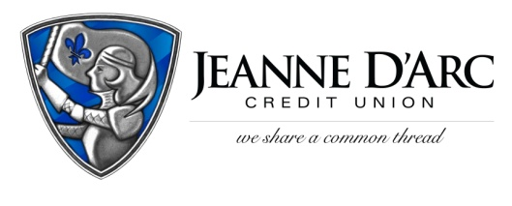

FOR IMMEDIATE RELEASE CONTACT: Robin Lorenzen
April 26, 2021 978-323-3226

Jeanne D’Arc Credit Union Announces
We Share a Common Thread Foundation Fundraiser

LOWELL, MA – Jeanne D’Arc Credit Union has announced the date for the We Share a Common Thread Foundation Annual Fundraiser. This year’s event will be held in a hybrid format beginning virtually on Tuesday, April 27^{th,} and will conclude with an in-person, walkthrough event on Wednesday, May 5 from 4:00-7:00 p.m. at Four Oaks Country Club in Dracut.
The fundraiser will feature popular items from past events including a silent auction, gift card pull, and the signature basket raffle with dozens of themed baskets prepared by Jeanne D’Arc employees. You can place your silent auction bids online at www.wsact.com. Raffle baskets can be previewed online and ticket sales will take place in person with safety protocols in place from 4:00 pm – 7:00 pm at Four Oaks Country Club on May 5th.
“A lot of organizations count on us for support, so hosting a hybrid event will allow us to start to bring our event back, and continue to support the local non-profits who need our help now more than ever,” said Mark Cochran, President & CEO of Jeanne D’Arc Credit Union.”
Jeanne D’Arc established the We Share a Common Thread Foundation in 2011 with the sole purpose of providing monetary support to local non-profit organizations, charities, causes, and events.
This annual event raises funds to directly benefit over one hundred local organizations. Last year’s fundraiser raised more than $80,000, and the Foundation disbursed the funds to 125 local organizations.
The Credit Union is honored to have Fiserv, Inc., a global provider of financial services technology, as its Common Thread Sponsor, the highest level of sponsorship.
For more information about the We Share A Common Thread Foundation and the annual fundraiser visit www.wsact.com.
About Jeanne D’Arc Credit Union:
Jeanne D’Arc Credit Union was established in 1912 and is a full-service, community-based financial cooperative. Locally owned by more than 92,000 members with $1.7 billion in assets, Jeanne D’Arc operates eight full-service branches in Lowell, Dracut (2), Tyngsboro, Chelmsford, Methuen and Westford, Massachusetts and Nashua, New Hampshire; high-school branches at Lowell High, Dracut High and Nashua High School South; a loan center in Lowell; and a mortgage center in Chelmsford.

