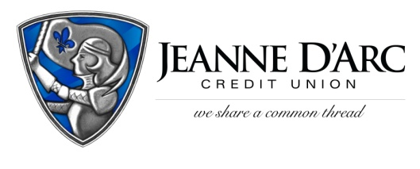

FOR IMMEDIATE RELEASE CONTACT: Robin Lorenzen
February 24, 2021 978-323-3226

Jeanne D’Arc Credit Union
Accepting College Scholarship Applications

LOWELL, MA – Jeanne D’Arc Credit Union is now accepting applications for its Annual MoneyStrong College Scholarship and the Cooperative Credit Union Association’s 2021 Credit Union College Scholarship Program.
The Credit Union’s MoneyStrong College Scholarship will award $10,000 in scholarships to applicants currently enrolled in college, as well as incoming freshmen for the Fall 2021 semester. Student applicants must be members of Jeanne D’Arc Credit Union to be eligible. Current college students can apply to receive $1,000 and high school seniors could receive $500.
The Cooperative Credit Union Association will be awarding six $1,500 scholarships across all chapters, with one scholarship awarded per chapter. Jeanne D’Arc Credit Union falls under the Massachusetts Chapter. Eligibility is limited to incoming college freshmen who will be enrolled in an undergraduate college degree program during the 2021-2022 academic year. Student applicants or their parents/guardians must be Jeanne D’Arc Credit Union members to be eligible.
More information including submission forms, instructions, required documentation, and application deadlines for each scholarship can be accessed at www.jdcu.com/scholarships.
###
About Jeanne D’Arc Credit Union:
Jeanne D’Arc Credit Union was established in 1912 and is a full-service, member-owned community-based financial cooperative with more than 91,000 members and $1.6 billion in assets. It operates eight full-service branches in Lowell, Dracut (2), Tyngsboro, Chelmsford, Methuen and Westford, Massachusetts and Nashua, New Hampshire; high-school branches at Lowell High, Dracut High and Nashua High School South; a loan center in Lowell; and a mortgage center in Chelmsford.

