United Federal Credit Union – Press Release
August 30, 2021

Contact: Diana Wake
Phone: (888) 982-1400 ext. 6891
Email: dwake@UnitedFCU.com
United Federal Credit Union, 150 Hilltop Road, St. Joseph, Michigan, 49085

United Federal Credit Union
Celebrates the Past While Planning for the Future
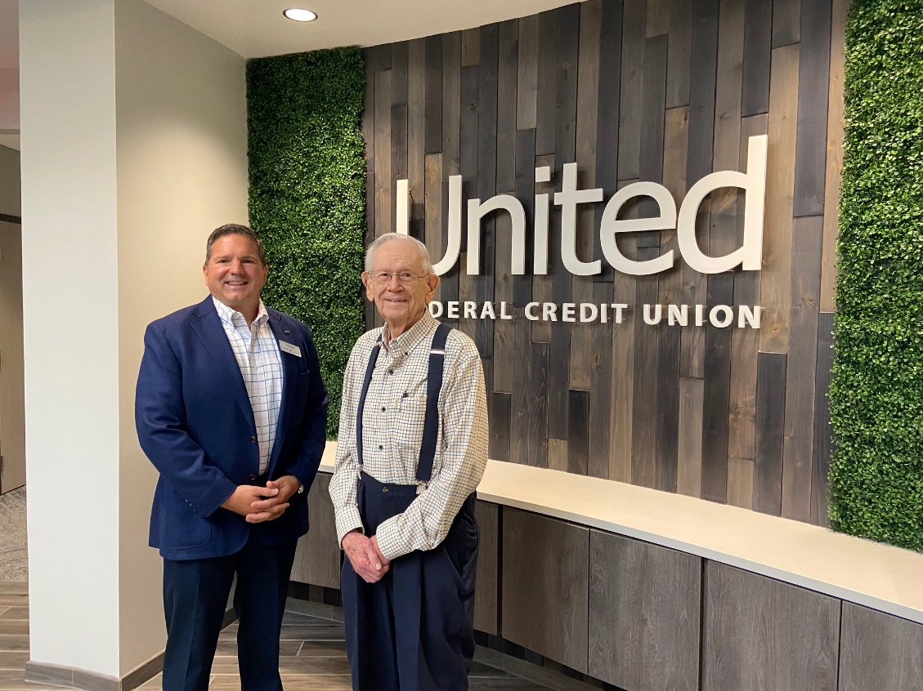
United Federal Credit Union founding member, John Conrad (right), tours
new headquarters in St. Joseph, MI with United President/CEO Terry O’Rourke (left)

ST. JOSEPH, Mich. – United Federal Credit Union has been at the center of immense progress over the past few years as it strives to deliver both personalized, in-person service balanced with an innovative digital experience to meet members’ growing expectations of what they need from their financial institution. The credit union recently opened a new, approximately 80,000 square feet headquarters in St. Joseph, Michigan to grow its diverse workforce, expanded its branch footprint in new towns—like South Bend, Indiana and Springdale, Arkansas—to include 42 locations in six states, and launched new remote banking services like its Mya AI-chatbot and upgrades to its mobile app. While United looks to its future and ability to help more members than ever before, it is also taking the time to reflect on the values it was built on and honor those who were pioneers in the credit union’s founding more than 70 years ago.
In July 2021, one of the founding members of United had the opportunity to visit the new St. Joseph headquarters. John Conrad, 95, saw first-hand how far the small credit union he helped found has grown. Conrad was the first auditor for Nineteen Hundred Employee Credit Union, which would go on to become United Federal Credit Union. He also served on the credit union’s board of directors, including time as board president.
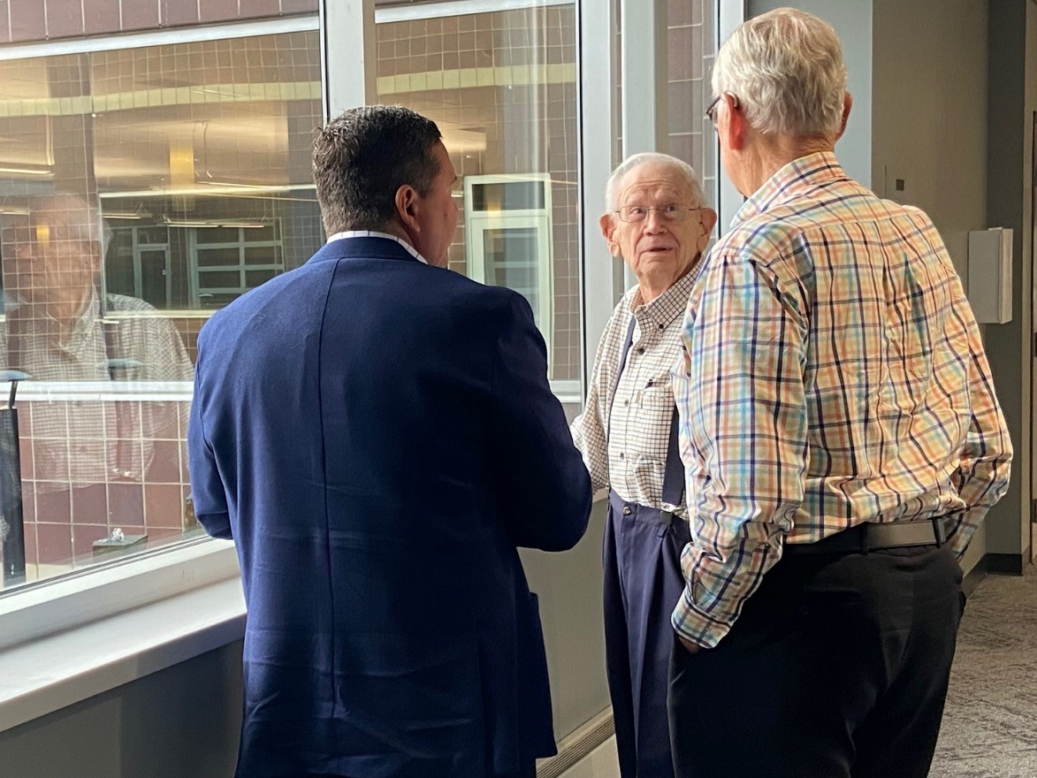
John Conrad (center) tours United’s new headquarters in St. Joseph, Michigan
Before he became a founding member of the credit union, Conrad was a World War II veteran who enrolled in a wounded veteran training program to learn accounting. He took those skills and landed a job in the payroll department for Whirlpool Corporation. While Conrad’s job made him a natural fit to help start the credit union, he said his real inspiration to find a way to help other people in the St. Joseph community came after a bad experience at another financial institution.
“I needed a loan to get a furnace for the house I was building”, Conrad recalled. “I went to the bank after I had been working on the house and I wasn’t dressed the best. I said ‘I’d like a loan,’. He [the banker] looked at my clothes and asked if I worked in a factory. I told him I worked in an office. He kept asking me questions, including who I worked for. I ended up getting the loan, but the way I was treated convinced me we needed a better way to get loans. The credit union did that for us, and I have been a member ever since.”
Conrad along with seven others officially founded Nineteen Hundred Employee Credit Union in 1949. At that time, it only served Whirlpool employees and had around 500 members. Instead of the expansive headquarters and dozens of branches United operates out of today, credit union business was conducted out of a lockbox kept inside a Whirlpool building until its first freestanding branch opened in October 1963.
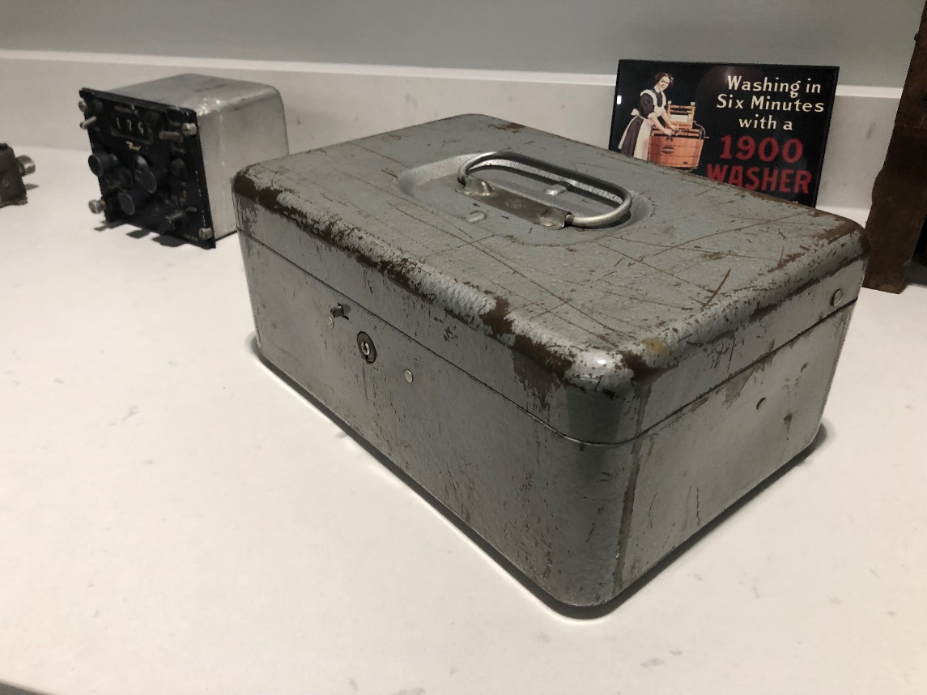
The original lockbox used by Nineteen Hundred Employee Credit Union in 1949
“We wanted to welcome people into the credit union and tell them what we could do for them. Make them feel at ease,” Conrad recalled about the drive of the founding members.
It is a mindset United President/CEO, Terry O’Rourke, said is just as important today as it was in the late 1940s.
“We want to strive to continue the legacy John, and our other founding members began—showing respect and kindness toward others we encounter. That includes not only our members, but one another no matter how busy we are.”
While the values the credit union was founded on have remained the same, the number of members United serves has grown to more than 180,000.
“I’m very proud. I’m amazed by how much United has grown,” Conrad said. “I’m proud as can be to see what’s happening with credit unions all over the country. It does my heart good.”
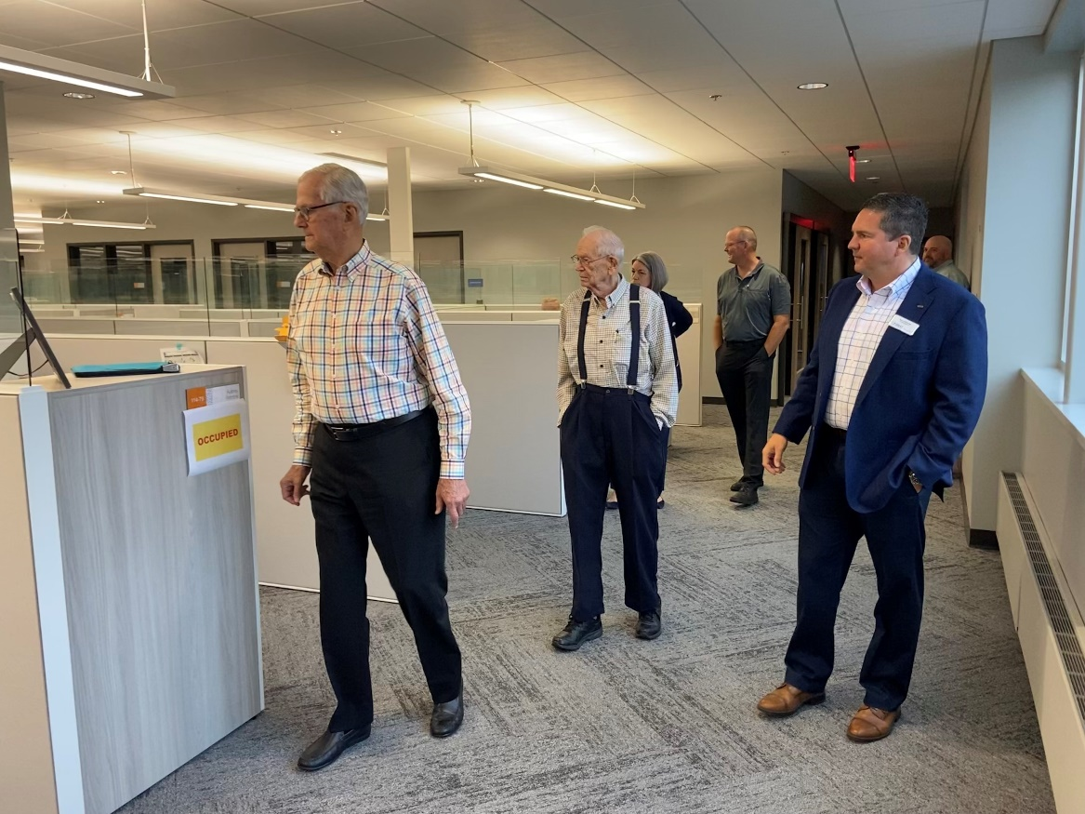
John Conrad (center) tours the new United headquarters in St. Joseph, Michigan
As United continues looking toward the future and how to continually improve the service it provides Members, Conrad had a piece of simple advice for current employees and leaders.
“Treat people with respect. Be nice to them,” Conrad stated. “And compliment people when they do their job right.”
Conrad’s guidance resonated with members of Team United, including O’Rourke who indicated that those words are a foundation for exceptional leadership.
“It was simple, but powerful advice,” said O’Rourke. “John’s words are something we can reflect on in our daily interaction with Members, each other, and the people in our community. It is also an important reminder that even though we’ve grown so much in 70 years, we come from humble beginnings built on timeless values.”
____________
About United
United Federal Credit Union has served its Members since 1949 by helping them to build a sound financial future. United consists of more than 180,000 Member/owners worldwide and manages assets in excess of $3.7 billion. Its corporate offices and main branch are in St. Joseph, Mich., with additional branches in Arkansas, Indiana, Michigan, Nevada, North Carolina, and Ohio. Federally insured by NCUA. Equal opportunity lender. Equal housing lender. For more information visit UnitedFCU.com

# # #

