United Federal Credit Union – Press Release
May 7, 2021

Contact: Diana Wake
Phone: (888) 982-1400 ext. 6891
Email: dwake@unitedfcu.com
United Federal Credit Union, 150 Hilltop Road, St. Joseph, Michigan, 49085

United Federal Credit Union Names Kristin McCarthy
Branch Manager at Bremen Highway Branch in South Bend

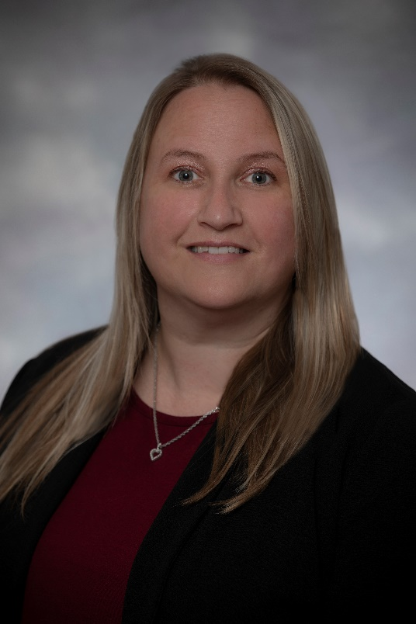
Kristin McCarthy, Branch Manager, Bremen Highway Branch

SOUTH BEND, Ind. – United Federal Credit Union (United) has named Kristin McCarthy to the position of Branch Manager at its Bremen Highway branch in South Bend at 3630 Bremen Highway.

As Branch Manager, McCarthy will be responsible for maintaining the performance of the branch, and providing leadership and supervision to staff.

McCarthy brings nearly 20 years of banking and financial experience to her new role. Prior to her role with United, she held several roles for INOVA Federal Credit Union in Elkhart, including the Director of Member Service Center and Branch Manager. She studied at Indiana Tech and has an associate of science degree in business administration and management.

McCarthy lives the credit union philosophy of ‘people helping people’ not only through member service, but also community involvement. She is an advocate for United’s community impact efforts supporting organizations such as the United Way of St. Joseph County, the Boys & Girls Club of St. Joseph County and other local non-profit groups.

____________
About United
United Federal Credit Union has served its Members since 1949 by helping them to build a sound financial future. United consists of more than 179,000 Member/owners worldwide and manages assets in excess of $3.3 billion. Its corporate offices and main branch are in St. Joseph, Mich., with additional branches in Arkansas, Indiana, Michigan, Nevada, North Carolina, and Ohio. Federally insured by NCUA. Equal opportunity lender. Equal housing lender. For more information visit www.unitedfcu.com

# # #

