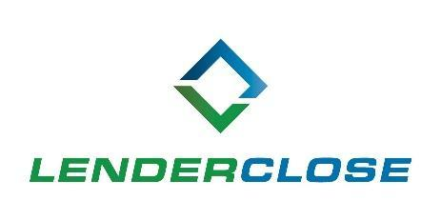

MEDIA CONTACTS:
Charlyne H. McWilliams/Ayesha Jamil
NEWS RELEASE
301.933.5567/678.781.7230
charlyne@williammills.com / ayesha@williammills.com
LenderClose Taps Stefanie Rupert to Join Board of Directors
Industry veteran brings more than 30 years of strategic insight to fintech firm

DES MOINES, April 13, 2021 – LenderClose, a real estate and home equity lending technology platform, has appointed Stefanie Rupert to its board of directors. The addition of Rupert brings the number of board members to seven.
Rupert has more than 30 years of experience in the banking and credit union industries, currently serving as president and CEO of Collins Community Credit Union. She has founded several credit union service organizations (CUSOs) and serves on an advisory council with Fiserv, providing recommendations on consumer engagement and online banking strategies.
“Stefanie brings a wealth of experience in the financial services industry,” said Omar Jordan, founder and CEO of LenderClose. “Her strategic insight will help LenderClose expand its outreach to community lenders dedicated to improving their real estate and home equity lending journey. We are excited to welcome Stefanie to our board of directors made up of key industry players.”
Rupert was recently featured as a Woman of Influence by the Corridor Business Journal and the Des Moines Business Record. She has received advanced degrees and industry accreditations from prominent universities such as Michigan State, The Wharton School of Business, Massachusetts Institute of Technology and Stanford University.
“I’m excited to join such a talented team at LenderClose, which is highly regarded by lenders nationwide,” Rupert said. “Collins Community Credit Union is a user and an investor in LenderClose. The ever-expanding competitive landscape community lenders face in order to meet borrowers’ expectations doesn’t start and end at the point-of-sale application. Borrower experience is a direct reflection of what happens behind the scenes at a financial institution from processing and underwriting to post-close. LenderClose’s vision aligns with the long-term success and vital contributions of traditional lenders to their communities.”
Rupert will serve on LenderClose’s board of directors alongside Jordan and Samantha Paxson, chief experience officer at CO-OP Financial Services; Nick Evens, President at The Veridian Group; Kris Kovacs, President and CEO at Constellation Digital Partners; Scott Hoekman, Co-Founder and Partner at Next Level Ventures; and, Benjamin Rempe, COO of LenderClose.
About LenderClose, Inc.
LenderClose is a technology-focused home equity and real estate lending platform which injects speed and efficiencies into the lending process, greatly enhancing the borrowing experience. Based in Des Moines, Iowa, the rapidly growing financial technology company is focused on providing credit unions and community banks innovative lending solutions and automated workflows. To learn more, visit lenderclose.com or follow us on LinkedIn or Twitter.
###

