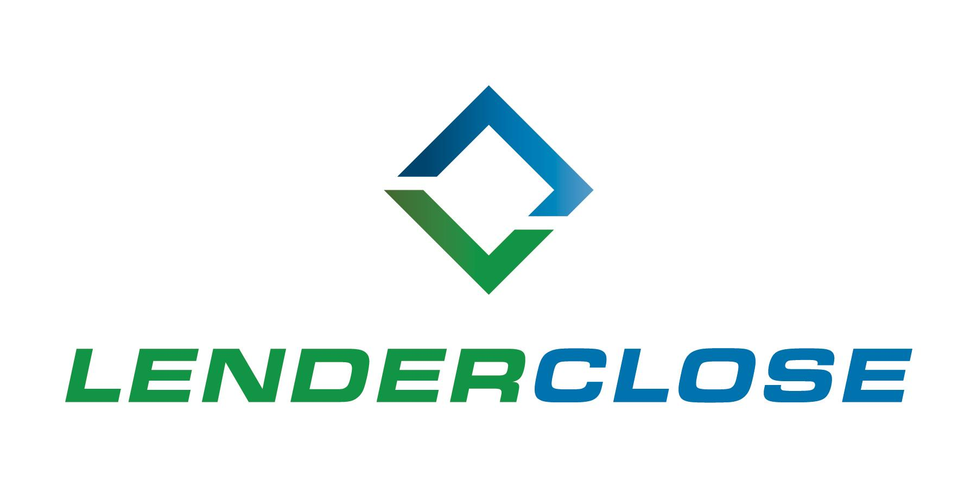
NEWS RELEASE

MEDIA CONTACTS:
Charlyne H. McWilliams/Ayesha Jamil
301.933.5567/678.781.7230
charlyne@williammills.com / ayesha@williammills.com
LenderClose Completes $10 million Series B Round
Fintech firm to expand reach and innovation with investment infusion
DES MOINES, March 23, 2021 – LenderClose, a real estate and home equity lending technology platform, has received a Series B funding round of $10 million in new capital. The investment comes from Next Level Ventures (VC Firm), Ardent Credit Union (Pa.), Strata Credit Union (Calif.), Tucson Federal Credit Union (Ariz.), Collins Community Credit Union (Iowa), Financial Plus Credit Union (Iowa), Serve Credit Union (Iowa) and Ascentra Credit Union (Iowa).
The Series B provides the funding required to focus on the company’s growth. LenderClose has experienced a rapid demand for its technology and innovative solutions, onboarding nearly 300 credit unions and community banks since its Series A in March 2018.
“Our number one priority is growth. Growth in our people, our executive leadership, revenue and most importantly, maximizing value to our partners and users through innovative technology solutions,” said Omar Jordan, founder and CEO. “Real estate and home equity lending continues to be a friction-filled process. At LenderClose, our commitment to leveraging technology to bring continuous improvement across the real estate lending journey allows us to focus on what matters most, lenders’ efficiency and their borrower experience. This has never been more important as the pandemic accelerated the demand for LenderClose, specifically our contactless lending solutions such as remote online notarization (RON).”
LenderClose recently launched its automated loan processing solution; HEx (Home Equity Express). HEx is built with a level of algorithm intelligence to ensure that the exceptions in the collateral data collected are earmarked for underwriting oversight and portfolio risk tolerance. The additional investment will expand the company’s R&D into process automation. The goal is to ultimately create a comprehensive lending solution, fully integrating every step of the lending process from pre-close to post-close.
“LenderClose is filling a deep need for speed and digitization in the lending lifecycle for credit unions and community lenders, enabling them to process more loans faster,” said Samantha Paxson, LenderClose board member and Chief Experience Officer of CO-OP Financial Services. “Their capital raise, and their ability, put that money to work across credit unions, makes it possible for our movement to rapidly expand loan volume without adding headcount, maximizing a credit union’s limited resources and moving at the pace members expect.”
LenderClose currently has more than 300 credit unions and community banks on its platform from coast to coast. The company continues to advance its growth potential and projects it will double its FI client count by end of 2022 and nearly double its staff headcount by Q4 2021.
“We have seen LenderClose grow faster than most fintechs in the industry have grown,” said Dave Tucker, Partner at Next Level Ventures. “The group has been able to accomplish so much with very little, since the Series A in March of 2018. This indicates that LenderClose has the right leadership in place and that the company is filling a major gap in the industry hence the aggressive client growth we’ve seen.”
About LenderClose, Inc.
LenderClose is a technology-focused home equity and real estate lending platform which injects speed and efficiencies into the lending process, greatly enhancing the borrowing experience. Based in Des Moines, Iowa, the rapidly growing financial technology company is focused on providing credit unions and community banks innovative lending solutions and automated workflows. To learn more, visit lenderclose.com or follow us on LinkedIn or Twitter.

###

