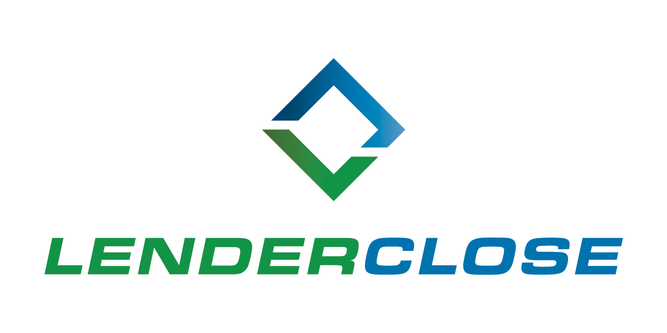

Text Box Text Box 4

**MEDIA CONTACTS:**

Charlyne H. McWilliams/Ayesha Jamil

301.933.5567/678.781.7230

charlyne@williammills.com / [ayesha@williammills.com](mailto:ayesha@williammills.com)

**LenderClose Grows Team 20% in Q1 2021, Aims to Double by Year End**

*Lending platform provider expands key departments*

**DES MOINES, May 18, 2021 –** LenderClose, a fintech engaged in providing technology solutions to home equity and real estate lenders, onboarded 10 new team members during the first quarter of 2021. With the company’s recent Series B capital raise of $10 million, LenderClose is investing heavily in top talent. The company continues to scale its client acquisition market share and aims to double its talent base by year end.

“We are committed to building a technology company that radically changes the way lending is approached. Building our team with top-level talent is crucial to ensuring we deliver,” said Omar Jordan, Founder/CEO. “Financial institutions are counting on LenderClose to fill the user experience gaps through its technology, in order to meet tomorrow’s borrower expectations.”

Meet LenderClose’s recent hires, moves and promotions:

Sales

* Chris Meade, Vice President of Client Relations
* Ken Dickerson, Vice President of Sales
* Fabio Rivas, Relationship Manager
* Jared DeMarino, Sales Executive
* Hunter Ingham, Sales Development Representative
* Matthew Manyvong, Sales Development Representative
* Tyus Mason, Sales Development Representative
* Alex Matthys, Sales Development Representative
* Faith Santee, Sales Development Representative

Product

* Tabitha Ochoa, Product Discovery Manager
* Eastyn Fitzgibbon, Product Manager
* Magnus Herweyer, Product Manager

Marketing

* Kate Gillum, Marketing Communications Coordinator

Operations

* Cameron Wilson, Vendor Operations Manager

**About LenderClose Inc.**

LenderClose is a technology-focused home equity and real estate lending platform which injects speed and efficiencies into the lending process, greatly enhancing the borrowing experience. Based in Des Moines, Iowa, the rapidly growing financial technology company is focused on providing credit unions and community banks innovative lending solutions and automated workflows. To learn more, visit [lenderclose.com](https://www.lenderclose.com/?utm_source=WMAgency&utm_medium=PR&utm_campaign=LenderClose+Grows+Team) follow us on [LinkedIn](https://www.linkedin.com/company/lenderclose) or [Twitter](http://twitter.com/lenderclose).

###