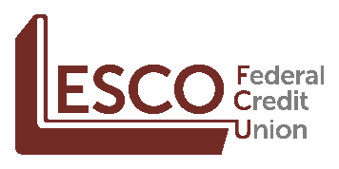

For Immediate Release
January 19, 2021

Lesco Federal Credit Union Joins cuBIZloan.com

Latrobe, PA and Princeton, NJ – cuBIZloan.com is excited to welcome Lesco Federal Credit Union to cuBIZloan’s member business and commercial loan referral program.
“We are looking forward to working with Lesco FCU to offer their members access to financing with business and SBA loan products,” said Murray Halperin, Managing Member of cuBIZloan.
cuBIZloan.com is a commercial and business lending service for businesses, investors, and not-for-profits. The referral program connects businesses to a trusted lending partner, with decisions made locally. We are committed to providing the business community access to capital.
Lesco Federal Credit Union is a community credit union in Latrobe, PA with membership open to all of Westmoreland County. The member experience includes superior financial products and services, low loan rates and exceptional customer service. Membership information and current rates may be obtained by calling 724-539-9744 or visiting lescofcu.com.
cuBIZloan.com is a partnership between Biz Lending & Insurance Center, Inc. and CrossState Solutions, Inc. Our mission is to help credit unions provide a full range of products specifically designed to satisfy a business owners’ financial and development needs. For more information visit cuBIZloan.com.
For more information contact:

Murray Halperin, Managing Member Neal Fenton

cuBIZloan, LLC Lesco Federal Credit Union

(609) 270-0200 (724) 539-9644

murrayh@cubizloan.com neal@lescofcu.com

###

