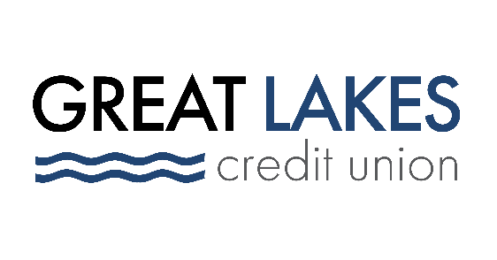

www.glcu.org
FOR IMMEDIATE RELEASE | Contact: Media Department  media@glcu.org  (847) 578-7324
Great Lakes Credit Union Sponsors 40th Annual Lunar New Year Celebration in Uptown Chicago

BANNOCKBURN, IL (Feb. 9, 2022) – On Saturday, Feb. 5, Great Lakes Credit Union (GLCU) served as a Parade and Event sponsor at the 40th Annual Lunar New Year celebration organized by Uptown United and 48th Ward Alderman Harry Osterman.

Hundreds of people gathered in Chicago’s Uptown neighborhood to celebrate East and Southeast Asian traditions and to welcome in the New Year, the Year of the Tiger. The event featured a parade, family activities, community-led speeches, and cultural performances.

Throughout the day, attendees enjoyed pop-up events hosted by local businesses and organizations. GLCU held a craft booth where families created Sakura trees and cherry blossoms, a common representation of a time of renewal and impending spring.

Long lines formed at local bakeries, flower shops, and restaurants. The parade was an opportunity to celebrate tradition and to support local businesses.

“GLCU had a wonderful experience working with Uptown United and the 48th Ward. It was extremely rewarding to see the event be a huge success,” said Brooke Wallace, Community Development Specialist. “We look forward to supporting the community in future events.”
GLCU expanded to serve the Uptown area in 2019. The area, which is a prominent cultural destination known for the Asia on Argyle district, serves as home to many Asian American-owned restaurants and shops.

“At its core, the annual Argyle Lunar New Year event is a celebration of community, and we are so grateful that Great Lakes Credit Union and their local Uptown Chapter participated in this year’s festivities,” said Greg Carroll, Director of Partnerships and Events at Uptown United. “By marching in the parade and offering an interactive art activity for visitors of all ages, GLCU proved to be a valuable partner in engaging the community.”
Great Lakes Credit Union is grateful for the opportunity to be part of the annual Lunar New Year Parade. GLCU is committed to financial empowerment for everyone and giving back to its communities is one of the credit union’s core values.

About Great Lakes Credit Union
Founded in 1938 and headquartered in Northern Illinois, GLCU is committed to financial empowerment for you. As a not-for-profit financial cooperative with over $1 billion in assets, GLCU is proud to serve more than 80,000 members in the Chicagoland and surrounding areas. Learn more about GLCU’s accounts, educational initiatives and community development programs at glcu.org

